THE PLACE-NAMES OF

MAGDALEN LAVER

Recorder: Alison Radford

Essex Place-names Project (Essex Society for Archaeology & History), 2012 (e-book).

www.essex.ac.uk/history/esah/essexplacenames

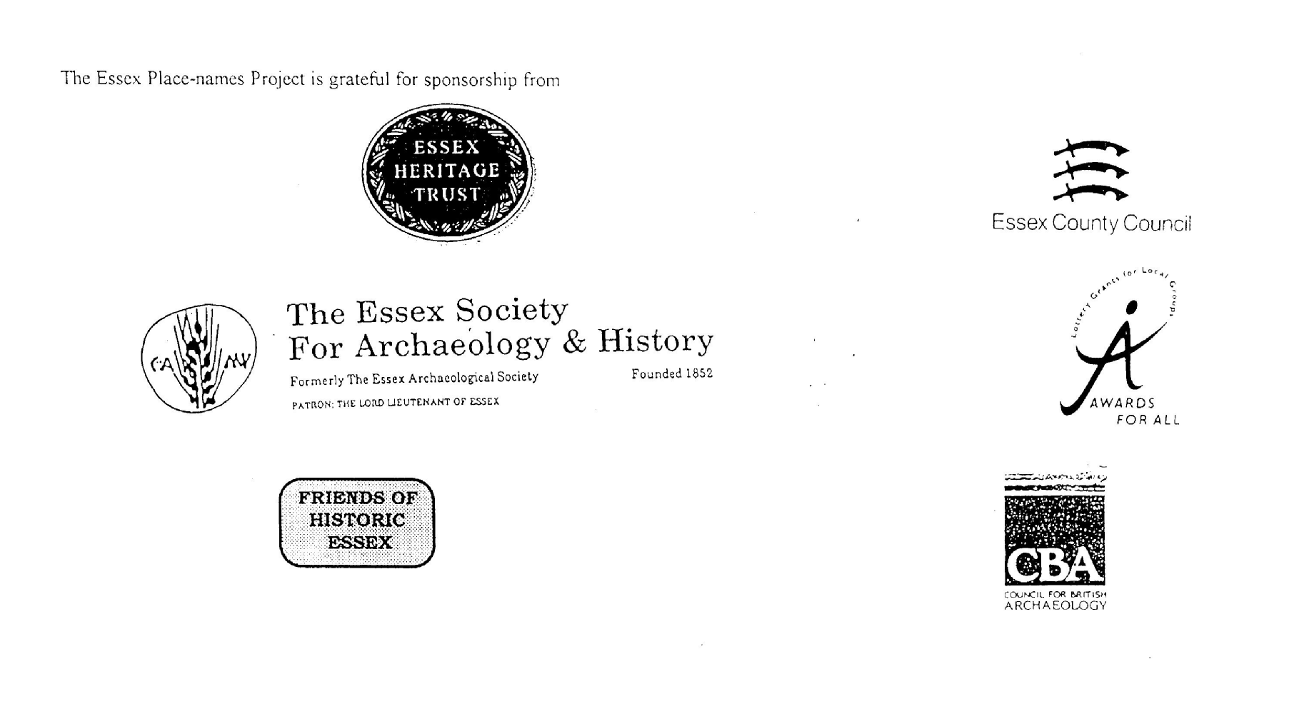

ESSEX PLACE-NAMES PROJECT.

The Essex Place-names Project is a County-wide survey to record place- and field-names from historical documents such as Tithe maps and apportionments, estate maps, sale
and auction catalogues, conveyances, terriers, deeds, rolls, inquisitions and surveys.

The second element of the Project is to investigate on-the-ground visible remains which correspond to the Place-names for actual or potential archaeological, agricultural and industrial
sites, and to record natural (topographical) and man-made features which may relate to the Place-name. This involves field-survey in rural and outside investigation in built-up areas.

It is anticipated that the Project will lead to identification of archaeological sites and lost historic buildings; it will enable analysis of indicators of early settlement, land holding, agricultural and industrial practices of the County. It will refine the more precise meaning of descriptive words and elements used by earlier settlers as they gave names appropriate to the topography of the landscape of their time.

For convenience the surveys are based on the parish, recognising that present civil parish boundaries are not necessarily identical to former ecclesiastical boundaries. Local Recorders
are supplied with templates of Record Forms to ensure consistency of recording across the County, and forward completed forms to a Central Coordinator for transfer to a county
computer database which is available to researchers on the internet at www.essex.ac.uk/history/esah/essexplacenames, and updated periodically.

This publication presents part of the information recorded from the Tithe or Estate Award and Map, and from other documents for this parish. The full record is contained on the master
database at Essex County Council (Historic Environment Section) and on the (above) website. Parish books are available to be downloaded from the website link ‘Books’ on the Home page. Please notify errors to the Project Coordinator at the Essex Record Office.

THE TITHE MAP AND APPORTIONMENT.

Since medieval times a tenth of the produce of land and stock had been paid by landholders to the church. At the Dissolution of the Monasteries, the property of many religious houses,
including the right to collect tithes, passed into lay hands. The Tithe Commutation Act which received Royal assent on 13th August 1836 abolished a rent payable in kind and
substituted rent-charges apportioned on each plot or parcel. The tithe-rent payable was assessed on the average value of wheat, barley and oats and was to fluctuate with price movements.

The commutation could be by voluntary agreement between the local owners and payers or, if agreement failed, could be compulsorily imposed by commissioners. A Valuer was to be
appointed to apportion the rent of each parcel of land and tenants could deduct that rent-charge from their rent paid to the landlord. The task fell to the Tithe Commissioners to produce a
map and an Apportionment (Award). A large-scale survey was produced for over 70% of England and Wales in the following 9 years, and about another 8% up to 1855. Most of the
parishes in Essex were surveyed. The map scales vary. The Award records ownership, tenancy and land-use, field by field and parcel by parcel (often quoting the field name) with the
ground area and rent-charge.

Land that was tithe-free tends to be less accurately mapped and contains few if any of the details recorded for those parcels subject to tithe. Rights of way and roads also tend to be
neglected. Boundaries of the tithe areas are shown as are some natural features such as streams, ponds, gardens, greens and commons. Buildings are often shown coloured red if dwellings
or grey if not. Because the Award may have been agreed only some time after the map was finished, discrepancies occur between the two. Enclosure Awards, when extant, usually date to the 18th and early 19th centuries. J.Kemble.
Reproduced by permission
of Essex County Council.

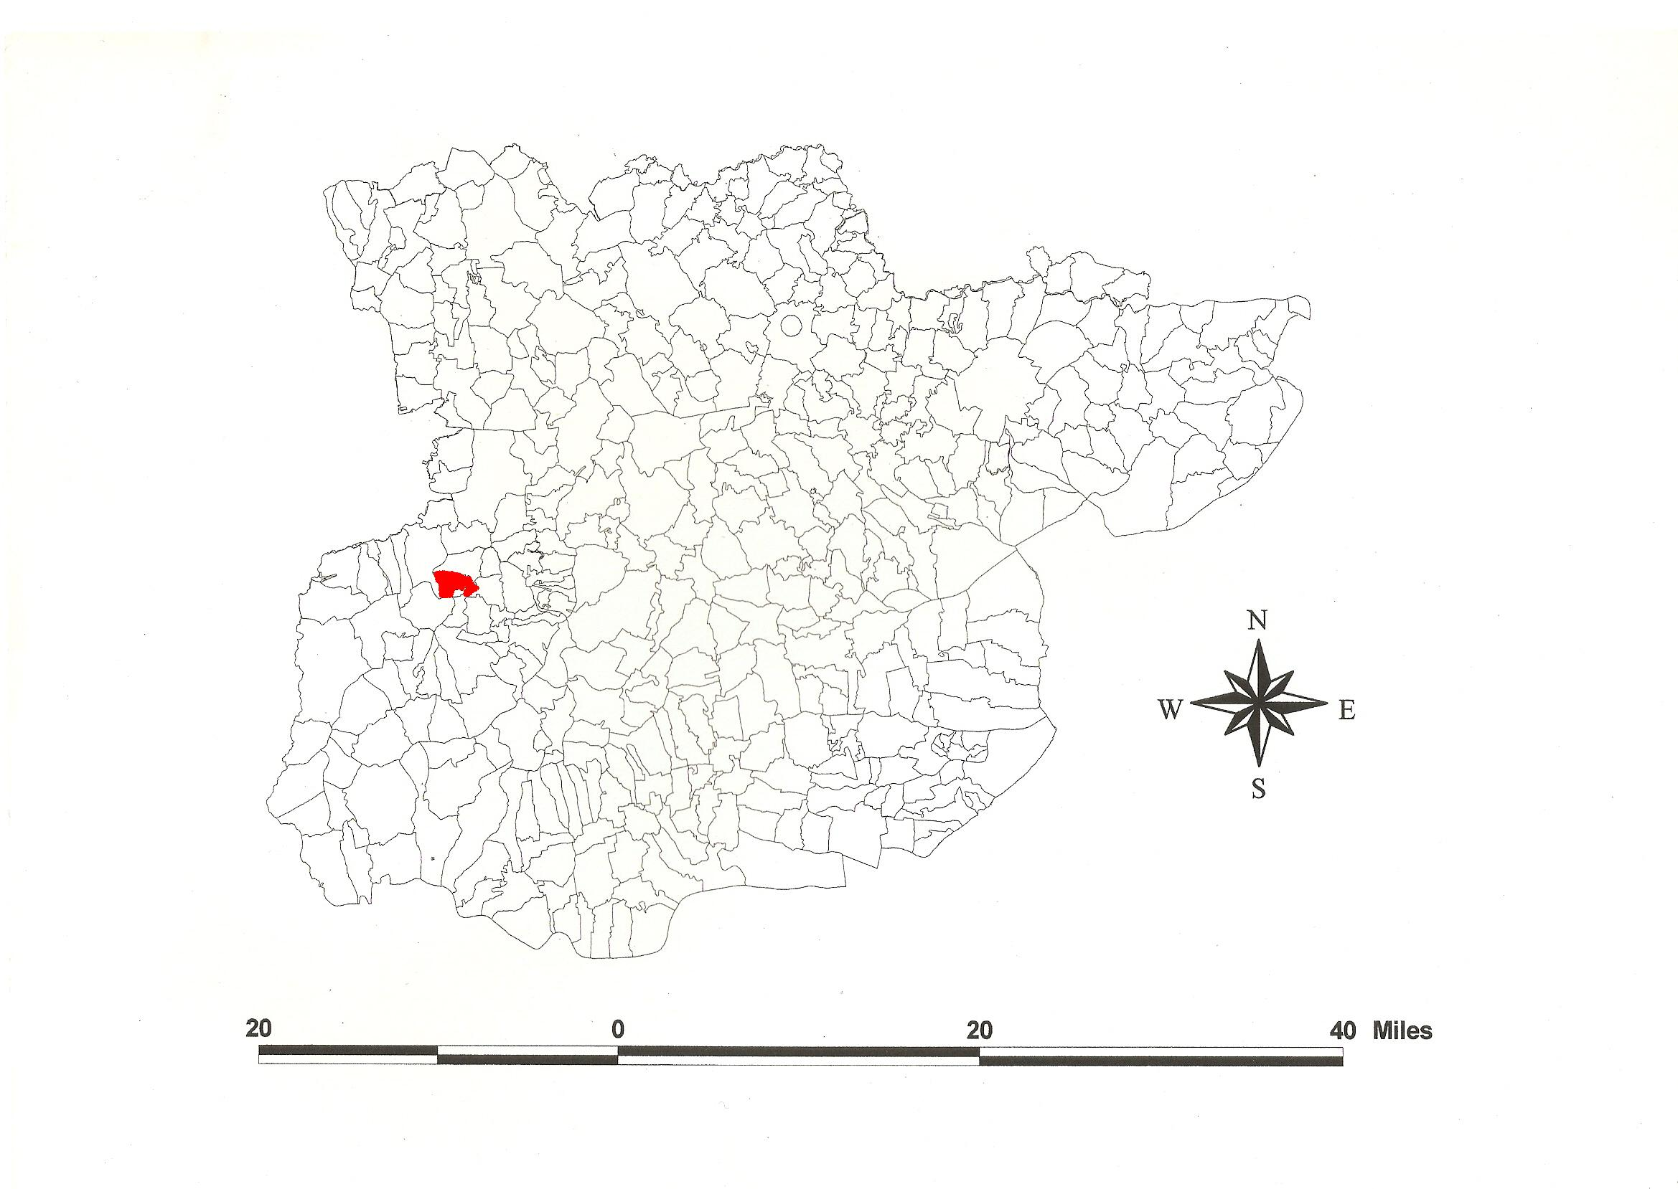
Magdalen Laver parish in the County of Essex.
Reproduced by permission
of Essex County Council.
211

The Parish of Magdalen Laver (in Ongar Hundred).

The Tithe Award of Magdalene Laver (Essex Record Office D/CT 211a), dared 1847, shows a rent-charge of £319-2-4, inclusive of glebe, payable to Rev. Richard Leonard Adams, rector. The total area of the parish measured 1000 acres of which 835 acres were arable, 150 acres meadow and pasture, 15 acres wood and 26 acres glebe. The Tithe Commissioners were J.W. Buller and R. Jones. The Valuers were Henry and Thomas Crawter of Cheshunt. The Assistant Tithe Commissioner was Thomas James Tatham.

The Tithe Map (ERO: D/CT 211 b), dated 1847, was surveyed at a scale of 26.6” to a mile by H. Crowter & Son of Cheshunt, Herts. It measures 87”x54”.

c.1010, Æthelflæd, daughter of ealdorman Ælfgar and second wife of King Edmund, willed 4 hides at Lagefare to St Pauls in London (Kemble, 2007). This was High and Little Laver, which were not in St Paul’s possession at Domesday, 1086, probably being one of the estates confiscated because of Æthelflæd’s assistance to her brother ealdorman Leofsige during his banishment for killing the king’s Reeve after he failed to negotiate acceptable terms of truce money with the Danes (Whitelock, 1930; Hart, 1971). In Domesday Book, 1086, Ralph of Tosny (in Eure) held Laghefara which Saxi, the huscarl, had held as a manor for one hide. This was perhaps Magdalen Laver (Morris, 1983). Watts (2004) translates this from Old English lagu-fær ‘stream passage’ referring to one of the several tributaries of Cripsey Brook. Magdalen Triket takes its name from the family of Simon and Hugo Trichet, Triket in 13th century (Reaney, 1935).

Ralph de Marcy was tenent t.Henry II (1154-89). Pharamus de Boulogne, great-grandson of Eustace (died 1183/4) held the manor. By inheritance it came to Sir William de Fiennes (died 1302). In 1352 the tenancy in chief was held by Elizabeth de Burgh of Clare. It came to Thomas Bataile (died 1439) of the Honour of Clare. It was held by John Barrington in 1536 of John, Earl of Oxford, of the Honour of Castle Hedingham. In 1614 Sir John Poyntz mortgaged the manor to Sir Edward Duncome. It was purchased by William Cole, Treasurer of St Thomas’s Hospital, sheriff of Essex (died 1729/30) (VCH, 1956).

The church dedicated to St Mary Magdalen has a blocked Norman window in the nave and Roman brick in the wall. The west tower was rebuilt in 1535. Bushes House of c.1500 was extended in 17th century. Wynters Armorie (Winters) began as a 14th century aisled hall (Pevsner, 2007).

The Hundred name in Domesday Book is 1086, Hangra, Angra. The wood at Aungre was bequeathed by Thurstan, son of Lustwine, in 1043x45 to his servants except the deer-enclosure and stud there, and to Thurgot the half hide which Ælfstan occupied (Whitelock, 1930). In 1068 Angra (Chipping Ongar) was confirmed to St Martin le Grand in London by William I (Hart, 1971). Reaney (1935) translates this from Old English anger, ‘grass land’. Christie (1926) sites the moot at Richard de Lucy’s castle at Chipping Ongar or at Toot Hill at Stanford Rivers where stands the mill mound.

Place- and field-names from the Map of Spencers Farm of John Archer (ERO: D/DB P4), dated 1770, and from other documents are shown against the Tithe Award names.

References:
Christie, M., 1926. Essex Hundred Moots. Trans Essex Archaeological Society, xviii (3), 192.
Hart, C., 1971. Early Charters of Essex. Leicester.
Kemble, J., 2007. Essex Place-names, Places, Streets & People. Historical Publications.
Morant, P., 1768. History & Antiquities of the County of Essex. i, 142.
Pevsner, N., Bettley, J., 2007. Buildings of England - Essex. Yale.
Reaney, P., 1935. Place-names of Essex. Cambridge.
Victoria Country History of Essex, 1956, iv, 103.
Watts, V., 2004. Dictionary of English Place-names. Cambridge.
Whitelock, D., 1930. Anglo-Saxon Wills. Cambridge. J. Kemble.

The Tithe Award Place-names of Magdalen Laver - by Parcel No.

Place-name | Alias | Fld No | Grd Ref | x | y | Acr | rd | pch | Land use | Owner | Occupier | Farm | Other information
Two cottages, gardens | [at 3 Ashes, 1777,C] | 1 | TL | 495 | 081 | 0 | 1 | 2 |  | Adams, Rev Richard Leonard | Weald, James
Tuckers Hoppit |  | 2 | TL | 496 | 081 | 0 | 3 | 5 | pasture | Adams, Rev Richard Leonard | Weald, James | Winters
Cats Croft |  | 3 | TL | 498 | 081 | 7 | 2 | 25 | arable | Wilson, John | Wilson, John | Rolls
No name |  | 4 | TL | 498 | 081 | 0 | 0 | 23 | arable | Adams, Rev Richard Leonard | Weald, James | Winters
Winters Farm Homestead | Wynters, 1592,Rntl | 5 | TL | 498 | 081 | 2 | 0 | 35 |  | Adams, Rev Richard Leonard | Weald, James | Winters | moated. Alice Winter, 1248,Ass
Stable field |  | 6 | TL | 499 | 083 | 2 | 1 | 30 | pasture | Adams, Rev Richard Leonard | Weald, James | Winters
Moat field |  | 7 | TL | 499 | 086 | 8 | 0 | 16 | arable | Adams, Rev Richard Leonard | Weald, James | Winters
Road |  | 8 | TL | 499 | 086 | 0 | 2 | 25 |  | Adams, Rev Richard Leonard | Weald, James | Winters
Homemead |  | 9 | TL | 497 | 084 | 4 | 3 | 10 | pasture | Adams, Rev Richard Leonard | Weald, James | Winters
Homemead |  | 10 | TL | 497 | 083 | 4 | 2 | 35 | pasture | Adams, Rev Richard Leonard | Weald, James | Winters
Five Ashes Homestead | Quinton, 1777,C | 11 | TL | 496 | 082 | 0 | 2 | 20 |  | Wilson, John | Wilson, John | Rolls
Home Croft & Middle Friveous |  | 12 | TL | 494 | 084 | 14 | 3 | 37 | arable | Wilson, John | Wilson, John | Rolls
Home Field |  | 13 | TL | 496 | 086 | 9 | 0 | 27 | arable | Adams, Rev Richard Leonard | Weald, James | Winters
Acre Mead |  | 14 | TL | 496 | 088 | 1 | 0 | 21 | pasture | Adams, Rev Richard Leonard | Weald, James | Winters
Six Acres |  | 15 | TL | 495 | 088 | 6 | 1 | 23 | arable | Adams, Rev Richard Leonard | Weald, James | Winters
Further Friveous |  | 16 | TL | 492 | 087 | 7 | 2 | 30 | arable | Wilson, John | Wilson, John | Rolls
Highwick |  | 17 | TL | 492 | 089 | 1 | 0 | 0 | arable | Gayner, Edward | Stone, Thomas
Cats Croft |  | 18 | TL | 493 | 088 | 4 | 0 | 5 | arable | Adams, Rev Richard Leonard | Weald, James | Winters
Wood |  | 19 | TL | 494 | 088 | 1 | 1 | 23 | wood | Adams, Rev Richard Leonard | Weald, James | Winters
Longcroft |  | 20 | TL | 496 | 089 | 4 | 1 | 17 | arable | Adams, Rev Richard Leonard | Weald, James | Winters
Highfield |  | 21 | TL | 498 | 089 | 10 | 1 | 27 | arable | Adams, Rev Richard Leonard | Weald, James | Winters
Shortland field |  | 22 | TL | 499 | 088 | 4 | 2 | 34 | arable | Adams, Rev Richard Leonard | Weald, James | Winters
Three Acre Mead |  | 23 | TL | 499 | 087 | 3 | 0 | 39 | pasture | Adams, Rev Richard Leonard | Weald, James | Winters
Hither & Nether Rolls |  | 24 | TL | 500 | 086 | 9 | 2 | 16 | arable | Wilson, John | Wilson, John | Rolls
Two Acre Mead |  | 25 | TL | 501 | 088 | 1 | 3 | 10 | arable | Wilson, John | Wilson, John | Rolls
Rolls Wood |  | 26 | TL | 501 | 089 | 2 | 3 | 39 | wood | Wilson, John | Wilson, John | Rolls
Great Newlands |  | 27 | TL | 503 | 090 | 6 | 1 | 11 | arable | Adams, Rev Richard Leonard | Weald, James | Winters
Stoneyfield |  | 27a | TL | 497 | 090 | 9 | 1 | 15 | arable | Adams, Rev Richard Leonard | Weald, James | Winters
Rushey Mead |  | 28 | TL | 502 | 089 | 1 | 3 | 16 | pasture | Meyer, Christian Paul | Lucking, Wm | Moulmans
Rolls Meadow |  | 29 | TL | 504 | 089 | 3 | 0 | 21 | pasture | Wilson, John | Wilson, John | Rolls
Little Newlands |  | 30 | TL | 505 | 090 | 2 | 2 | 18 | arable | Adams, Rev Richard Leonard | Weald, James | Winters
Wood |  | 31 | TL | 505 | 091 | 1 | 2 | 17 | wood | Adams, Rev Richard Leonard | Weald, James | Winters
Rainbow |  | 32 | TL | 506 | 090 | 1 | 0 | 30 | arable | Meyer, Christian Paul | Lucking, Wm | Moulmans
Great Belsons Wood | Belsnam Wood, 1875,OS | 33 | TL | 507 | 091 | 6 | 1 | 36 | wood | Meyer, Christian Paul | Lucking, Wm | Moulmans
Great Belson |  | 34 | TL | 509 | 090 | 11 | 0 | 0 | arable | Meyer, Christian Paul | Lucking, Wm | Moulmans
Long Mead |  | 35 | TL | 507 | 089 | 4 | 2 | 29 | pasture | Meyer, Christian Paul | Lucking, Wm | Moulmans
Round Mead |  | 36 | TL | 509 | 086 | 2 | 0 | 24 | pasture | Meyer, Christian Paul | Lucking, Wm | Moulmans
Rushey Mead |  | 37 | TL | 507 | 086 | 2 | 0 | 27 | pasture | Meyer, Christian Paul | Lucking, Wm | Moulmans
Great Buttons |  | 38 | TL | 506 | 088 | 12 | 2 | 11 | arable | Meyer, Christian Paul | Lucking, Wm | Moulmans
Little Buttons |  | 39 | TL | 504 | 087 | 6 | 1 | 35 | arable | Meyer, Christian Paul | Lucking, Wm | Moulmans
Prickland Shot |  | 40 | TL | 502 | 086 | 6 | 3 | 11 | arable | Meyer, Christian Paul | Lucking, Wm | Moulmans
Poor Field |  | 41 | TL | 502 | 085 | 7 | 0 | 21 | arable | Meyer, Christian Paul | Lucking, Wm | Moulmans
Horse Nails |  | 42 | TL | 501 | 084 | 4 | 2 | 30 | arable | Adams, Rev Richard Leonard | Weald, James | Winters
Home Pasture |  | 43 | TL | 500 | 082 | 2 | 1 | 17 | pasture | Wilson, John | Wilson, John | Rolls
Cottage, garden |  | 44 | TL | 500 | 082 | 0 | 0 | 16 |  | Flower, execs of | Walker, Henry
Dove House Croft |  | 45 | TL | 501 | 082 | 6 | 1 | 15 | arable | Wilson, John | Wilson, John | Rolls
Garden |  | 46 | TL | 500 | 080 | 0 | 2 | 27 |  | Wilson, John | Wilson, John | Rolls
Rolls Farm Homestead | Rolles, 1539,M; Rose, 1777,C | 47 | TL | 500 | 080 | 2 | 0 | 38 |  | Wilson, John | Wilson, John | Rolls
Enclosure from Waste |  | 48 | TL | 500 | 080 | 0 | 1 | 22 | arable | Wilson, John | Wilson, John | Rolls
Hither Post End field |  | 49 | TL | 501 | 080 | 6 | 1 | 2 | arable | Wilson, John | Wilson, John | Rolls
James Croft |  | 50 | TL | 503 | 082 | 6 | 1 | 2 | arable | Meyer, Christian Paul | Lucking, Wm | Moulmans
Slipe |  | 51 | TL | 504 | 084 | 1 | 2 | 0 | pasture | Wilson, John | Wilson, John | Rolls
Topmead |  | 52 | TL | 506 | 086 | 2 | 0 | 28 | pasture | Meyer, Christian Paul | Lucking, Wm | Moulmans
Great Barn field |  | 53 | TL | 508 | 084 | 11 | 1 | 36 | arable | Meyer, Christian Paul | Lucking, Wm | Moulmans
Little Barn field |  | 54 | TL | 507 | 084 | 6 | 2 | 12 | arable | Meyer, Christian Paul | Lucking, Wm | Moulmans
Hedge Row field |  | 55 | TL | 509 | 085 | 4 | 2 | 28 | arable | Cozens, Mary Ann | Gapes, Wm
Two Acre Mead |  | 56 | TL | 510 | 086 | 2 | 0 | 20 | pasture | Burford, Rev Wm John | Larter, John |  | glebe
Lower Well field |  | 57 | TL | 510 | 087 | 5 | 0 | 13 | arable | Burford, Rev Wm John | Larter, John |  | glebe
Upper Well field |  | 58 | TL | 511 | 089 | 4 | 1 | 15 | arable | Burford, Rev Wm John | Larter, John |  | glebe
No name |  | 59 | TL | 510 | 088 | 2 | 1 | 25 | pasture | Hancock, Henry | Moreton, John
The Seven Acres |  | 60 | TL | 508 | 083 | 7 | 3 | 33 | arable | Burford, Rev Wm John | Larter, John |  | glebe
Long Croft |  | 61 | TL | 507 | 081 | 2 | 2 | 2 | arable | Redington, Thomas | Redington,Thomas | Humphreys
Gooseland Shot |  | 62 | TL | 506 | 081 | 6 | 3 | 15 | arable | Meyer, Christian Paul | Lucking, Wm | Moulmans
Homefield |  | 63 | TL | 505 | 079 | 3 | 2 | 23 | pasture | Meyer, Christian Paul | Lucking, Wm | Moulmans
Cottage field |  | 64 | TL | 504 | 079 | 3 | 3 | 9 | arable | Meyer, Christian Paul | Lucking, Wm | Moulmans
Further Post field |  | 65 | TL | 503 | 080 | 6 | 3 | 14 | arable | Wilson, John | Wilson, John | Rolls
Cottage, garden |  | 66 | TL | 503 | 078 | 0 | 0 | 21 |  | Samson, S | Lucking, Thomas
Two cottages, gardens |  | 67 | TL | 503 | 078 | 0 | 0 | 29 |  | Algar, Wm Hill | Pryor, Peter; another
No name |  | 68 | TL | 503 | 077 | 0 | 3 | 20 | pasture | Algar, Wm Hill | Gapes, Wm
No name |  | 69 | TL | 503 | 077 | 2 | 1 | 18 | pasture | Samson, S | Lucking, Wm
Redwells |  | 70 | TL | 501 | 077 | 5 | 3 | 32 | arable | Redington, Thomas | Redington,Thomas | Humphreys
Further Broadcroft |  | 71 | TL | 500 | 077 | 5 | 2 | 36 | pasture | Wilson, John | Wilson, John | Rolls
Hither Broadcroft |  | 72 | TL | 499 | 078 | 6 | 2 | 19 | pasture | Wilson, John | Wilson, John | Rolls
Two cottages, gardens |  | 73 | TL | 498 | 078 | 0 | 2 | 25 |  | Algar, Wm Hill | Pryor, George; another
Poor House field |  | 74 | TL | 497 | 079 | 4 | 1 | 9 | arable | Wilson, John | Wilson, John | Rolls
No name |  | 75 | TL | 499 | 076 | 1 | 1 | 7 | pasture | White, Algernon Holt | White, Algernon Holt
Gibbs |  | 76 | TL | 500 | 076 | 4 | 3 | 15 | arable | Redington, Thomas | Redington,Thomas | Humphreys
Great Chapel |  | 76a | TL | 499 | 073 | 2 | 1 | 0 | pasture | White, Algernon Holt | White, Algernon Holt
Rolls Cow Ridden |  | 77 | TL | 501 | 073 | 7 | 1 | 10 | arable | Frere, George Edward | Banks, Benjamin | Greens
Cow Ridden |  | 78 | TL | 503 | 073 | 8 | 1 | 38 | arable | Frere, George Edward | Banks, Benjamin | Greens
Middle Shot |  | 79 | TL | 503 | 075 | 2 | 1 | 2 | pasture | Redington, Thomas | Redington,Thomas | Humphreys
Cottage, garden |  | 80 | TL | 503 | 076 | 1 | 0 | 8 | pasture | Samson, S | Lucking, Wm
No name |  | 81 | TL | 503 | 076 | 1 | 3 | 4 | pasture | Algar, Wm Hill | Gapes, Wm
Hoppitt |  | 82 | TL | 504 | 077 | 1 | 3 | 20 | pasture | Meyer, Christian Paul | Lucking, Wm | Moulmans
Moulmans Farm Homestead | Mallmens, Mawmens, 1542,Waller; Mollmans, 1875,OS | 83 | TL | 505 | 077 | 0 | 1 | 28 | pasture | Meyer, Christian Paul | Lucking, Wm | Moulmans | OE mal land = copyhold held by quit-rent
The Ley |  | 84 | TL | 504 | 076 | 2 | 1 | 29 | pasture | Redington, Thomas | Redington,Thomas | Humphreys
Bramble Hill |  | 85 | TL | 505 | 076 | 3 | 0 | 1 | pasture | Frere, George Edward | Banks, Benjamin | Greens
Goose Croft |  | 86 | TL | 505 | 074 | 5 | 0 | 13 | arable | Frere, George Edward | Banks, Benjamin | Greens
Wear Mead |  | 87 | TL | 505 | 073 | 4 | 1 | 7 | arable | Frere, George Edward | Banks, Benjamin | Greens
Little Field |  | 88 | TL | 506 | 071 | 1 | 1 | 23 | pasture | Frere, George Edward | Banks, Benjamin | Greens
Great Follicey |  | 89 | TL | 505 | 071 | 5 | 3 | 3 | arable | Ewing, James | Edwards, James | Magdalen Laver Hall
Eight Acre Field |  | 90 | TL | 506 | 071 | 7 | 1 | 38 | arable | Wedd, Sarah | James, John | Whites
Lears Hall |  | 91 | TL | 502 | 071 | 9 | 1 | 17 | arable | Frere, George Edward | Banks, Benjamin | Greens
Little Field |  | 92 | TL | 502 | 070 | 2 | 2 | 7 | arable | Ewing, James | Edwards, James | Magdalen Laver Hall
Follicey |  | 93 | TL | 502 | 069 | 2 | 2 | 4 | arable | Frere, George Edward | Banks, Benjamin | Greens
Four Acres |  | 94 | TL | 502 | 068 | 4 | 1 | 20 | arable | Wedd, Sarah | James, John | Whites
Upper Spring |  | 95 | TL | 503 | 066 | 3 | 2 | 14 | arable | Frere, George Edward | Banks, Benjamin | Greens
No name |  | 96 | TL | 504 | 065 | 5 | 1 | 31 | arable | White, Algernon Holt | White, Algernon Holt
Long Mead |  | 97 | TL | 503 | 064 | 1 | 1 | 30 | pasture | White, Algernon Holt | White, Algernon Holt
Three Acre Mead |  | 98 | TL | 506 | 064 | 3 | 1 | 9 | pasture | Frere, George Edward | Banks, Benjamin | Greens
Lower Spring |  | 99 | TL | 505 | 065 | 5 | 0 | 38 | arable | Frere, George Edward | Banks, Benjamin | Greens
Ten Acres |  | 100 | TL | 505 | 067 | 9 | 2 | 17 | arable | Wedd, Sarah | James, John | Whites
Seven Acre Field |  | 101 | TL | 506 | 065 | 7 | 2 | 27 | arable | Wedd, Sarah | James, John | Whites
Four Acre Mead |  | 102 | TL | 507 | 067 | 5 | 0 | 0 | pasture | Frere, George Edward | Banks, Benjamin | Greens
Three cottages, gardens |  | 103 | TL | 509 | 067 | 0 | 0 | 38 |  | King, execs of | Britten, Wm; others
Lamberts |  | 104 | TL | 508 | 067 | 2 | 3 | 25 | pasture | Frere, George Edward | Banks, Benjamin | Greens
Horrods |  | 105 | TL | 508 | 068 | 4 | 0 | 7 | arble, pstre | Samson, S | Lucking, Wm
Maggots |  | 106 | TL | 508 | 070 | 4 | 3 | 9 | arable | Frere, George Edward | Banks, Benjamin | Greens
Kitchen Croft |  | 107 | TL | 508 | 070 | 3 | 2 | 21 | pasture | Frere, George Edward | Banks, Benjamin | Greens
Two Acres |  | 108 | TL | 507 | 072 | 1 | 3 | 1 | pasture | Frere, George Edward | Banks, Benjamin | Greens
Greens Farm Homestead | Grenes, 1592,Rntl | 109 | TL | 506 | 072 | 0 | 3 | 8 |  | Frere, George Edward | Banks, Benjamin | Greens | John Grene, 1468,Deed
Cart House Meadow |  | 110 | TL | 507 | 073 | 1 | 2 | 35 | pasture | Frere, George Edward | Banks, Benjamin | Greens
Five Roods |  | 111 | TL | 507 | 074 | 3 | 3 | 21 | pasture | Redington, Thomas | Redington,Thomas | Humphreys
Bean Croft |  | 112 | TL | 507 | 076 | 5 | 1 | 39 | pasture | Redington, Thomas | Redington,Thomas | Humphreys
The Slipe |  | 113 | TL | 508 | 076 | 0 | 3 | 37 | pasture | Redington, Thomas | Redington,Thomas | Humphreys
Rye Grass Field |  | 114 | TL | 506 | 075 | 1 | 1 | 32 | pasture | Cozens, Mary Ann | Gapes, Wm
Upper Nine Acres |  | 115 | TL | 509 | 074 | 5 | 0 | 8 | arable | Redington, Thomas | Redington,Thomas | Humphreys
Lower Nine Acres |  | 116 | TL | 507 | 072 | 4 | 0 | 0 | arable | Redington, Thomas | Redington,Thomas | Humphreys
Two cottages, gardens |  | 117 | TL | 507 | 072 | 0 | 1 | 2 |  | Cozens, Mary Ann | Tucker, John; another |  | Poor House in 1708 (Church Guide)
Burnt Field |  | 118 | TL | 509 | 071 | 3 | 3 | 4 | arable | Frere, George Edward | Banks, Benjamin | Greens
Old House field |  | 119 | TL | 509 | 069 | 3 | 0 | 35 | arable | Frere, George Edward | Banks, Benjamin | Greens
Scapelands |  | 120 | TL | 510 | 068 | 4 | 3 | 16 | pasture | Redington, Thomas | Redington,Thomas | Humphreys
Two cottages & field |  | 121 | TL | 509 | 067 | 1 | 0 | 6 | arable | Lucking, Wm | Lucking, Wm; another
Luckings Mead |  | 122 | TL | 511 | 067 | 1 | 2 | 9 | pasture | Algar, Wm Hill | Church, Samuel | Kents
Kitchen Mead |  | 123 | TL | 511 | 066 | 3 | 3 | 11 | pasture | Algar, Wm Hill | Church, Samuel | Kents
Kents Farm Homestead | Kents, 1554,Rntl | 124 | TL | 512 | 066 | 0 | 1 | 24 |  | Algar, Wm Hill | Church, Samuel | Kents | Walter le Kenteys, of High Laver, 1256,FF
Cartshed Meadow |  | 125 | TL | 512 | 066 | 1 | 3 | 9 | pasture | Algar, Wm Hill | Church, Samuel | Kents
Long Mead |  | 126 | TL | 513 | 065 | 1 | 3 | 31 | pasture | Algar, Wm Hill | Church, Samuel | Kents
Great Mead |  | 127 | TL | 513 | 066 | 2 | 0 | 33 | pasture | Algar, Wm Hill | Church, Samuel | Kents
Bridge Mead |  | 128 | TL | 514 | 065 | 2 | 0 | 5 | pasture | Chapman, James | Pyne, Benjamin
Thistlecroft |  | 129 | TL | 513 | 067 | 4 | 2 | 15 | pasture | Algar, Wm Hill | Church, Samuel | Kents
Stackyard |  | 130 | TL | 512 | 067 | 0 | 0 | 21 |  | Algar, Wm Hill | Church, Samuel | Kents
Cowhouse Mead |  | 131 | TL | 511 | 067 | 2 | 0 | 7 | pasture | Algar, Wm Hill | Church, Samuel | Kents
Scapelands |  | 132 | TL | 512 | 068 | 4 | 1 | 0 | arable | Redington, Thomas | Redington,Thomas | Humphreys
Lower Ridden |  | 133 | TL | 513 | 068 | 6 | 3 | 37 | arable | Wedd, Sarah | James, John | Whites
Newlands |  | 134 | TL | 511 | 069 | 5 | 0 | 8 | arable | Frere, George Edward | Banks, Benjamin | Greens
Four Acres |  | 135 | TL | 511 | 071 | 4 | 1 | 21 | arable | Frere, George Edward | Banks, Benjamin | Greens
Middle Ridden |  | 136 | TL | 513 | 071 | 8 | 2 | 33 | arable | Wedd, Sarah | James, John | Whites
Great Ridden |  | 137 | TL | 515 | 073 | 14 | 1 | 5 | arable | Wedd, Sarah | James, John | Whites
Upper Ridden |  | 138 | TL | 513 | 074 | 5 | 1 | 2 | arable | Wedd, Sarah | James, John | Whites
Pear Tree field |  | 139 | TL | 511 | 074 | 1 | 1 | 24 | pasture | Cozens, Mary Ann | Gapes, Wm
No name |  | 140 | TL | 510 | 074 | 1 | 2 | 0 | pasture | Cozens, Mary Ann | Gapes, Wm
No name |  | 141 | TL | 510 | 075 | 0 | 2 | 36 | pasture | Cozens, Mary Ann | Gapes, Wm
The Green Man Homestead | Green Man P.H., 1875,OS | 142 | TL | 511 | 075 | 0 | 1 | 8 | inn | Cozens, Mary Ann | Gapes, Wm
No name |  | 143 | TL | 510 | 076 | 0 | 3 | 19 | pasture | Cozens, Mary Ann | Gapes, Wm
Whitebreads |  | 144 | TL | 509 | 077 | 3 | 0 | 24 | pasture | Redington, Thomas | Redington,Thomas | Humphreys
Hoppitt |  | 145 | TL | 507 | 077 | 1 | 2 | 2 | pasture | Redington, Thomas | Redington,Thomas | Humphreys
Humphreys Homestead | Humfreys, 1592,Rntl | 146 | TL | 507 | 076 | 1 | 0 | 7 |  | Redington, Thomas | Redington,Thomas | Humphreys | John Humfrey, 1285,Ass. Licensed for Presbyterian ministry in 1709.
Orchard |  | 147 | TL | 506 | 076 | 0 | 2 | 32 | pasture | Redington, Thomas | Redington,Thomas | Humphreys
Homestead |  | 148 | TL | 506 | 076 | 0 | 1 | 0 |  | Meyer, Christian Paul | Lucking, Wm | Moulmans
Backfield |  | 149 | TL | 506 | 077 | 2 | 0 | 19 | arable | Meyer, Christian Paul | Lucking, Wm | Moulmans
Longcroft |  | 150 | TL | 507 | 081 | 5 | 3 | 0 | arable | Burford, Rev Wm John | Larter, John |  | glebe
Broadland | Broadlands, 1770,D/DB P4 | 151 | TL | 512 | 076 | 10 | 3 | 5 | arable | Houblon, JohnArcher | Larter, John | Spencers
Four Acre Piece |  | 152 | TL | 509 | 078 | 8 | 0 | 2 | arable | Redington, Thomas | Redington,Thomas | Humphreys
Home Croft |  | 153 | TL | 512 | 077 | 2 | 2 | 4 | arable | Redington, Thomas | Redington,Thomas | Humphreys
Five Acre Nicholls |  | 154 | TL | 512 | 076 | 3 | 2 | 26 | arable | Ewing, James | Edwards, James | Magdalen Laver Hall
Four Acre Nicholls |  | 155 | TL | 514 | 076 | 5 | 0 | 12 | arable | Ewing, James | Edwards, James | Magdalen Laver Hall
Pear Tree Woodlands |  | 156 | TL | 514 | 078 | 9 | 3 | 21 | arable | Houblon, JohnArcher | Larter, John | Spencers
Three Acre Nicholls |  | 157 | TL | 512 | 078 | 3 | 2 | 26 | arable | Ewing, James | Edwards, James | Magdalen Laver Hall
Messfield | Maise field,1770,D/DB P4 | 158 | TL | 511 | 080 | 14 | 1 | 34 | arable | Redington, Thomas | Redington,Thomas | Humphreys
Gate Croft | Gate Croft, 1770,D/DB P4 | 159 | TL | 512 | 083 | 8 | 0 | 10 | pasture | Redington, Thomas | Redington,Thomas | Humphreys
Stable field |  | 160 | TL | 510 | 082 | 3 | 3 | 9 | arable | Burford, Rev Wm John | Larter, John |  | Glebe
Garden |  | 161 | TL | 510 | 083 | 0 | 2 | 13 |  | Burford, Rev Wm John | Larter, John |  | Glebe
Glebe Homestead | Parsonnage, 1777,C | 162 | TL | 510 | 083 | 0 | 3 | 2 |  | Burford, Rev Wm John | Larter, John |  | Glebe
Perry field | Perryfelde, 1554,Rntl | 163 | TL | 512 | 084 | 12 | 1 | 24 | arable | Houblon, JohnArcher | Larter, John | Spencers
No name |  | 164 | TL | 512 | 086 | 1 | 0 | 38 | pasture | Houblon, JohnArcher | Larter, John | Spencers
Shrubbery |  | 165 | TL | 513 | 086 | 0 | 1 | 7 |  | Ewing, James | Edwards, James | Magdalen Laver Hall
Church Meadow |  | 166 | TL | 513 | 085 | 4 | 1 | 10 | pasture | Houblon, JohnArcher | Larter, John | Spencers
Church Hoppitt |  | 167 | TL | 514 | 082 | 1 | 1 | 12 | pasture | Houblon, JohnArcher | Larter, John | Spencers
Spencers Farm Homestead | Spencers, 1554,Rntl | 168 | TL | 514 | 082 | 1 | 1 | 22 |  | Houblon, JohnArcher | Larter, John | Spencers | John le Spenser, of Moreton, 1339,FF
Barn Hoppitt |  | 169 | TL | 514 | 082 | 0 | 2 | 23 | pasture | Houblon, JohnArcher | Larter, John | Spencers
Barn Field |  | 170 | TL | 514 | 081 | 1 | 2 | 8 | arable | Houblon, JohnArcher | Larter, John | Spencers
Kitchen Croft | Kitching Croft,1770,D/DB P4 | 171 | TL | 515 | 082 | 5 | 0 | 14 | pasture | Houblon, JohnArcher | Larter, John | Spencers
Church Field |  | 172 | TL | 516 | 084 | 3 | 2 | 26 | arable | Houblon, JohnArcher | Larter, John | Spencers
Roadway |  | 173 | TL | 516 | 082 | 0 | 0 | 23 |  | Houblon, JohnArcher | Larter, John | Spencers
Woodpiece |  | 174 | TL | 517 | 081 | 7 | 0 | 25 | arable | Houblon, JohnArcher | Larter, John | Spencers
Nine Acres |  | 175 | TL | 515 | 080 | 10 | 3 | 24 | arable | Houblon, JohnArcher | Larter, John | Spencers
Crook Mill |  | 176 | TL | 516 | 079 | 3 | 2 | 23 | arable | Houblon, JohnArcher | Larter, John | Spencers
Two Acre Meadow |  | 177 | TL | 518 | 079 | 2 | 2 | 2 | pasture | Houblon, JohnArcher | Larter, John | Spencers
Twelve Acres |  | 178 | TL | 518 | 078 | 12 | 3 | 8 | arable | Houblon, JohnArcher | Larter, John | Spencers
Hoppitt |  | 179 | TL | 520 | 076 | 1 | 0 | 8 | pasture | Wedd, Sarah | James, John | Whites
White Farm Homestead | Whites, 1554,Rntl | 180 | TL | 520 | 076 | 0 | 3 | 31 |  | Wedd, Sarah | James, John | Whites | Thomas Whyte, 1381,SubRoll
Three cottages, gardens |  | 181 | TL | 520 | 076 | 0 | 1 | 16 |  | Lake, Stracey | Nash, Richard; others
No name |  | 182 | TL | 520 | 075 | 0 | 1 | 8 | pasture | Lake, Stracey | Henson, Joseph
Black Croft |  | 183 | TL | 519 | 075 | 5 | 2 | 36 | arable | Wedd, Sarah | James, John | Whites
Little Croft |  | 184 | TL | 519 | 073 | 1 | 0 | 14 | arable | Wedd, Sarah | James, John | Whites
Tumble Acre |  | 185 | TL | 519 | 076 | 1 | 0 | 5 | arable | Wedd, Sarah | James, John | Whites
Ruskins |  | 186 | TL | 517 | 075 | 5 | 0 | 12 | arable | Ewing, James | Edwards, James | Magdalen Laver Hall
Penny Croft |  | 187 | TL | 516 | 076 | 1 | 2 | 10 | arable | Redington, Thomas | Redington,Thomas | Humphreys
Black Croft |  | 188 | TL | 521 | 077 | 4 | 0 | 34 | arable | Ewing, James | Edwards, James | Magdalen Laver Hall
Cakebread Mead | Cakebread Meadow, 1770, D/DB P4 | 189 | TL | 521 | 079 | 7 | 1 | 35 | pasture | Houblon, JohnArcher | Larter, John | Spencers
Horse Croft |  | 190 | TL | 523 | 077 | 7 | 3 | 18 | pasture | Wedd, Sarah | James, John | Whites
Upper Three Acres |  | 191 | TL | 524 | 076 | 3 | 1 | 2 | arable | Rayment, Stacey | Hart, Thomas
Longfield |  | 192 | TL | 524 | 074 | 7 | 0 | 5 | arable | Rayment, Stacey | Hart, Thomas
Homefield |  | 193 | TL | 525 | 074 | 4 | 2 | 0 | arable | Rayment, Stacey | Hart, Thomas
The Hoppitt |  | 194 | TL | 525 | 076 | 0 | 3 | 14 | pasture | Rayment, Stacey | Hart, Thomas
Homestead | Lande, 1254,Ass; Lunds, 1875,OS | 195 | TL | 525 | 075 | 0 | 0 | 34 |  | Rayment, Stacey | Hart, Thomas |  | John de la Lund de Wauda, 1255, Ass. Middle English launde = glade
Horsecroft |  | 196 | TL | 525 | 075 | 0 | 2 | 12 | pasture | Wedd, Sarah | James, John | Whites
Brook field |  | 197 | TL | 524 | 079 | 6 | 0 | 18 | arable | Crooks, Sarah | Hazelwood, Wm | Ashlings
Great Downs |  | 198 | TL | 523 | 080 | 3 | 1 | 21 | arable | Crooks, Sarah | Hazelwood, Wm | Ashlings
Lower Downs |  | 199 | TL | 522 | 080 | 1 | 0 | 27 | arable | Ewing, James | Edwards, James | Magdalen Laver Hall
Downs |  | 200 | TL | 521 | 082 | 7 | 2 | 16 | arable | Wedd, Sarah | James, John | Whites
Woodpiece |  | 201 | TL | 519 | 082 | 9 | 0 | 6 | arable | Ewing, James | Edwards, James | Magdalen Laver Hall
Longmead |  | 202 | TL | 518 | 081 | 6 | 3 | 0 | pasture | Houblon, JohnArcher | Larter, John | Spencers
Round Platt |  | 203 | TL | 517 | 085 | 8 | 3 | 0 | pasture | Ewing, James | Edwards, James | Magdalen Laver Hall
Red Mill Shot |  | 204 | TL | 520 | 084 | 5 | 3 | 10 | arable | Ewing, James | Edwards, James | Magdalen Laver Hall | "Stone coffin & human remains found", 1875,OS
Stack Piece |  | 205 | TL | 518 | 086 | 3 | 2 | 31 | arable | Ewing, James | Edwards, James | Magdalen Laver Hall
Park Field |  | 206 | TL | 515 | 086 | 17 | 0 | 37 | pasture | Ewing, James | Edwards, James | Magdalen Laver Hall | “Site of Manor House”, 1875,OS
Church & Yard | [St Mary Magdalen] | 207 | TL | 515 | 086 | 0 | 3 | 36 |  | Magdalen Laver parish | churchwardens of
Pond |  | 208 | TL | 513 | 087 | 0 | 3 | 3 |  | Ewing, James | Edwards, James | Magdalen Laver Hall
Pond |  | 209 | TL | 513 | 087 | 0 | 0 | 29 |  | Ewing, James | Edwards, James | Magdalen Laver Hall
Magdalen Laver Hall Farm Homestead | Lawefar (e) Triket, 1218,Fees | 210 | TL | 513 | 087 | 0 | 3 | 18 |  | Ewing, James | Edwards, James | Magdalen Laver Hall | Owner: Jo. Cozens esq, 1777,C
Homestead |  | 211 | TL | 513 | 087 | 0 | 3 | 35 |  | Ewing, James | Edwards, James | Magdalen Laver Hall
Roadway |  | 212 | TL | 513 | 087 | 0 | 1 | 17 |  | Ewing, James | Edwards, James
Walkfield |  | 213 | TL | 513 | 089 | 8 | 0 | 22 | arable | Ewing, James | Edwards, James | Magdalen Laver Hall
Lodge & shrubbery |  | 214 | TL | 513 | 088 | 0 | 0 | 23 |  | Ewing, James | Edwards, James | Magdalen Laver Hall
Twelve Acres |  | 215 | TL | 515 | 090 | 13 | 0 | 4 | arable | Ewing, James | Edwards, James | Magdalen Laver Hall
Garden |  | 216 | TL | 517 | 091 | 0 | 0 | 13 |  | Ewing, James | Edwards, James | Magdalen Laver Hall
Tom Whites |  | 217 | TL | 517 | 091 | 6 | 3 | 19 | pasture | Ewing, James | Edwards, James | Magdalen Laver Hall
Church Hoppitt |  | 218 | TL | 515 | 088 | 3 | 2 | 33 | pasture | Ewing, James | Edwards, James | Magdalen Laver Hall
Seven Acres Mill Hill |  | 219 | TL | 518 | 090 | 7 | 0 | 26 | arable | Ewing, James | Edwards, James | Magdalen Laver Hall
Shrubbery |  | 220 | TL | 519 | 090 | 0 | 1 | 20 |  | Ewing, James | Edwards, James | Magdalen Laver Hall
Ten Acre Mill Hill |  | 221 | TL | 520 | 087 | 11 | 1 | 15 | arable | Ewing, James | Edwards, James | Magdalen Laver Hall
Little Langley |  | 222 | TL | 522 | 086 | 15 | 2 | 24 | arable | Ewing, James | Edwards, James | Magdalen Laver Hall
No name |  | 223 | TL | 521 | 089 | 11 | 0 | 38 | arable | Gilbertson, James Matthias | Cook, Ann
Dool Field |  | 224 | TL | 520 | 091 | 3 | 2 | 19 | arable | Gilbertson, James Matthias | Cook, Ann
The Mead |  | 225 | TL | 523 | 091 | 6 | 2 | 20 | arable | Gilbertson, James Matthias | Cook, Ann
Twelve Acres |  | 226 | TL | 524 | 089 | 12 | 3 | 10 | arable | Gilbertson, James Matthias | Cook, Ann
Upper Seven Acres |  | 227 | TL | 526 | 086 | 8 | 3 | 10 | arable | Ewing, James | Edwards, James | Magdalen Laver Hall
Dool Field |  | 228 | TL | 525 | 084 | 7 | 0 | 26 | arable | Crooks, Sarah | Hazelwood, Wm | Ashlings
Bellsland Down |  | 229 | TL | 526 | 082 | 1 | 3 | 11 | arable | Crooks, Sarah | Hazelwood, Wm | Ashlings
Inghams |  | 230 | TL | 527 | 081 | 5 | 0 | 10 | arable | Crooks, Sarah | Hazelwood, Wm | Ashlings
Shoemakers Field |  | 231 | TL | 527 | 079 | 4 | 0 | 36 | arable | Crooks, Sarah | Hazelwood, Wm | Ashlings
Longlands |  | 232 | TL | 529 | 080 | 9 | 0 | 25 | arable | Chaplin, Thomas | Chaplin, Thomas | Bush's
Homefield |  | 233 | TL | 529 | 081 | 6 | 2 | 11 | arable | Crooks, Sarah | Hazelwood, Wm | Ashlings
Hoppitt |  | 234 | TL | 529 | 083 | 0 | 2 | 25 | pasture | Crooks, Sarah | Hazelwood, Wm | Ashlings
Ashlings Farm Homestead | Astelyns, 1554,Rntl; Harsland, 1777,C | 235 | TL | 529 | 083 | 1 | 0 | 6 |  | Crooks, Sarah | Hazelwood, Wm | Ashlings | Richard Ascelyn, 1321, 1324, FF
Lower Gate Croft |  | 236 | TL | 530 | 083 | 7 | 0 | 0 | pasture | Chaplin, Thomas | Chaplin, Thomas | Bush's
Orchard |  | 237 | TL | 531 | 084 | 0 | 1 | 11 | pasture | Chaplin, Thomas | Chaplin, Thomas | Bush's
Bush's Farm Homestead | Bushey, 1777,C | 238 | TL | 531 | 084 | 1 | 2 | 23 |  | Chaplin, Thomas | Chaplin, Thomas | Bush's
Two Acres |  | 239 | TL | 532 | 085 | 2 | 0 | 28 | pasture | Chaplin, Thomas | Chaplin, Thomas | Bush's
Lower Ley |  | 240 | TL | 530 | 086 | 10 | 0 | 8 | arable | Ewing, James | Edwards, James | Magdalen Laver Hall
Great Langley |  | 241 | TL | 528 | 085 | 17 | 0 | 3 | arable | Ewing, James | Edwards, James | Magdalen Laver Hall
Lower Seven Acres |  | 242 | TL | 528 | 087 | 8 | 0 | 15 | arable | Ewing, James | Edwards, James | Magdalen Laver Hall
No name |  | 243 | TL | 529 | 089 | 2 | 3 | 25 | arable | Clark, Charles | Clark, Charles
Six Acres |  | 244 | TL | 530 | 090 | 6 | 0 | 0 | arable | Clark, Charles | Clark, Charles
No name |  | 245 | TL | 530 | 089 | 2 | 0 | 24 | arable | Clark, Charles | Clark, Charles
Homestead | Start Farm, 1875,OS | 246 | TL | 530 | 087 | 0 | 1 | 7 |  | Clark, Charles | Clark, Charles
Small Gains |  | 247 | TL | 535 | 083 | 7 | 1 | 4 | pasture | Chaplin, Thomas | Chaplin, Thomas | Bush's
No name |  | 248 | TL | 536 | 086 | 2 | 0 | 34 | pasture | Budworth, Rev Richard Philip | Byford, Wm
No name |  | 249 | TL | 537 | 086 | 2 | 1 | 37 | pasture | Budworth, Rev Richard Philip | Byford, Wm
Two cottages, gardens |  | 250 | TL | 537 | 085 | 0 | 1 | 7 |  | Spencer, Sarah | Spencer, Sarah
No name |  | 251 | TL | 537 | 085 | 0 | 2 | 37 | pasture | Spencer, Sarah | Spencer, Sarah
Brick Kiln Mead | Brick(h)ill meade, 1554-92,Rntl | 252 | TL | 538 | 081 | 9 | 0 | 23 | pasture | Chaplin, Thomas | Chaplin, Thomas | Bush's
Homestead, three cottages |  | 253 | TL | 538 | 080 | 0 | 3 | 6 |  | Chaplin, Thomas | Chaplin, Thomas | Bush's
Brick Kiln Hoppitt | Brickell, 1554-92,Rntl | 254 | TL | 538 | 079 | 7 | 1 | 1 | pasture | Chaplin, Thomas | Chaplin, Thomas | Bush's
New Piece |  | 255 | TL | 538 | 080 | 2 | 1 | 17 | arable | Chaplin, Thomas | Chaplin, Thomas | Bush's
Horse Pasture |  | 256 | TL | 536 | 076 | 9 | 2 | 6 | pasture | Chaplin, Thomas | Chaplin, Thomas | Bush's
Mill Mead |  | 256a | TL | 537 | 074 | 8 | 2 | 18 | pasture | Chaplin, Thomas | Chaplin, Thomas | Bush's
Park Field |  | 257 | TL | 535 | 077 | 2 | 1 | 31 | pasture | Chaplin, Thomas | Chaplin, Thomas | Bush's
Two cottages, gardens |  | 258 | TL | 533 | 077 | 0 | 0 | 34 |  | Hart, Thomas | Hart, Thomas
Homestead |  | 259 | TL | 533 | 077 | 0 | 0 | 35 |  | Hart, Thomas | Hart, Thomas
Nine Acre Mead |  | 260 | TL | 534 | 075 | 9 | 0 | 6 | pasture | Hart, Thomas | Hart, Thomas
Four Acre Mead |  | 261 | TL | 534 | 072 | 4 | 0 | 32 | pasture | Hart, Thomas | Hart, Thomas
Barters Field |  | 262 | TL | 532 | 075 | 8 | 2 | 33 | pasture | Hart, Thomas | Hart, Thomas
Three & half acres |  | 263 | TL | 533 | 072 | 3 | 3 | 17 | arable | Hart, Thomas | Hart, Thomas
Three & half acres |  | 264 | TL | 533 | 071 | 1 | 3 | 30 | pasture | Hart, Thomas | Hart, Thomas
Three & half acres |  | 265 | TL | 533 | 071 | 1 | 0 | 24 | pasture | Hart, Thomas | Hart, Thomas
Four & half acres |  | 266 | TL | 531 | 072 | 4 | 3 | 4 | arable | Hart, Thomas | Hart, Thomas
The Great Mead |  | 267 | TL | 529 | 071 | 10 | 0 | 17 | pasture | Elwes, George | Gingell, George
No name |  | 268 | TL | 528 | 073 | 4 | 2 | 11 | arable | Hart, Thomas | Hart, Thomas
Seven Acres |  | 269 | TL | 530 | 073 | 8 | 0 | 0 | arable | Hart, Thomas | Hart, Thomas
Five Acres |  | 270 | TL | 531 | 076 | 6 | 0 | 25 | arable | Hart, Thomas | Hart, Thomas
Seven Acres |  | 271 | TL | 529 | 076 | 7 | 0 | 29 | arable | Hart, Thomas | Hart, Thomas
Grouts field |  | 272 | TL | 530 | 077 | 4 | 1 | 26 | arable | Rayment, Stacey | Hart, Thomas
Barn Hoppitt |  | 273 | TL | 528 | 077 | 1 | 3 | 0 | pasture | Rayment, Stacey | Hart, Thomas
Barn Mead |  | 274 | TL | 527 | 076 | 2 | 1 | 3 | pasture | Rayment, Stacey | Hart, Thomas
Barn Mead |  | 275 | TL | 532 | 083 | 10 | 2 | 6 | pasture | Chaplin, Thomas | Chaplin, Thomas
Cottage, garden |  | 276 | TL | 537 | 085 | 0 | 0 | 14 |  | Budworth, Rev Richard Philip | Byford, Wm

For abbreviations, see Reaney, P., 1935. Place-names of Essex. Cambridge; and Kemble, J., 2007. Essex Place-names, Places, Streets & People. Historical Publications, p 151.

The Tithe Award Place-names of Magdalen Laver - by Owner.

Place-name | Alias | Fld No | Grd Ref | x | y | Acr | rd | pch | Land use | Owner | Occupier | Farm | Other information
Two cottages, gardens | [at 3 Ashes, 1777,C] | 1 | TL | 495 | 081 | 0 | 1 | 2 |  | Adams, Rev Richard Leonard | Weald, James
Homemead |  | 10 | TL | 497 | 083 | 4 | 2 | 35 | pasture | Adams, Rev Richard Leonard | Weald, James | Winters
Home Field |  | 13 | TL | 496 | 086 | 9 | 0 | 27 | arable | Adams, Rev Richard Leonard | Weald, James | Winters
Acre Mead |  | 14 | TL | 496 | 088 | 1 | 0 | 21 | pasture | Adams, Rev Richard Leonard | Weald, James | Winters
Six Acres |  | 15 | TL | 495 | 088 | 6 | 1 | 23 | arable | Adams, Rev Richard Leonard | Weald, James | Winters
Cats Croft |  | 18 | TL | 493 | 088 | 4 | 0 | 5 | arable | Adams, Rev Richard Leonard | Weald, James | Winters
Wood |  | 19 | TL | 494 | 088 | 1 | 1 | 23 | wood | Adams, Rev Richard Leonard | Weald, James | Winters
Tuckers Hoppit |  | 2 | TL | 496 | 081 | 0 | 3 | 5 | pasture | Adams, Rev Richard Leonard | Weald, James | Winters
Longcroft |  | 20 | TL | 496 | 089 | 4 | 1 | 17 | arable | Adams, Rev Richard Leonard | Weald, James | Winters
Highfield |  | 21 | TL | 498 | 089 | 10 | 1 | 27 | arable | Adams, Rev Richard Leonard | Weald, James | Winters
Shortland field |  | 22 | TL | 499 | 088 | 4 | 2 | 34 | arable | Adams, Rev Richard Leonard | Weald, James | Winters
Three Acre Mead |  | 23 | TL | 499 | 087 | 3 | 0 | 39 | pasture | Adams, Rev Richard Leonard | Weald, James | Winters
Great Newlands |  | 27 | TL | 503 | 090 | 6 | 1 | 11 | arable | Adams, Rev Richard Leonard | Weald, James | Winters
Stoneyfield |  | 27a | TL | 497 | 090 | 9 | 1 | 15 | arable | Adams, Rev Richard Leonard | Weald, James | Winters
Little Newlands |  | 30 | TL | 505 | 090 | 2 | 2 | 18 | arable | Adams, Rev Richard Leonard | Weald, James | Winters
Wood |  | 31 | TL | 505 | 091 | 1 | 2 | 17 | wood | Adams, Rev Richard Leonard | Weald, James | Winters
No name |  | 4 | TL | 498 | 081 | 0 | 0 | 23 | arable | Adams, Rev Richard Leonard | Weald, James | Winters
Horse Nails |  | 42 | TL | 501 | 084 | 4 | 2 | 30 | arable | Adams, Rev Richard Leonard | Weald, James | Winters
Winters Farm Homestead | Wynters, 1592,Rntl | 5 | TL | 498 | 081 | 2 | 0 | 35 |  | Adams, Rev Richard Leonard | Weald, James | Winters | moated. Alice Winter, 1248,Ass
Stable field |  | 6 | TL | 499 | 083 | 2 | 1 | 30 | pasture | Adams, Rev Richard Leonard | Weald, James | Winters
Moat field |  | 7 | TL | 499 | 086 | 8 | 0 | 16 | arable | Adams, Rev Richard Leonard | Weald, James | Winters
Road |  | 8 | TL | 499 | 086 | 0 | 2 | 25 |  | Adams, Rev Richard Leonard | Weald, James | Winters
Homemead |  | 9 | TL | 497 | 084 | 4 | 3 | 10 | pasture | Adams, Rev Richard Leonard | Weald, James | Winters
Luckings Mead |  | 122 | TL | 511 | 067 | 1 | 2 | 9 | pasture | Algar, Wm Hill | Church, Samuel | Kents
Kitchen Mead |  | 123 | TL | 511 | 066 | 3 | 3 | 11 | pasture | Algar, Wm Hill | Church, Samuel | Kents
Kents Farm Homestead | Kents, 1554,Rntl | 124 | TL | 512 | 066 | 0 | 1 | 24 |  | Algar, Wm Hill | Church, Samuel | Kents | Walter le Kenteys, of High Laver, 1256,FF
Cartshed Meadow |  | 125 | TL | 512 | 066 | 1 | 3 | 9 | pasture | Algar, Wm Hill | Church, Samuel | Kents
Long Mead |  | 126 | TL | 513 | 065 | 1 | 3 | 31 | pasture | Algar, Wm Hill | Church, Samuel | Kents
Great Mead |  | 127 | TL | 513 | 066 | 2 | 0 | 33 | pasture | Algar, Wm Hill | Church, Samuel | Kents
Thistlecroft |  | 129 | TL | 513 | 067 | 4 | 2 | 15 | pasture | Algar, Wm Hill | Church, Samuel | Kents
Stackyard |  | 130 | TL | 512 | 067 | 0 | 0 | 21 |  | Algar, Wm Hill | Church, Samuel | Kents
Cowhouse Mead |  | 131 | TL | 511 | 067 | 2 | 0 | 7 | pasture | Algar, Wm Hill | Church, Samuel | Kents
No name |  | 68 | TL | 503 | 077 | 0 | 3 | 20 | pasture | Algar, Wm Hill | Gapes, Wm
No name |  | 81 | TL | 503 | 076 | 1 | 3 | 4 | pasture | Algar, Wm Hill | Gapes, Wm
Two cottages, gardens |  | 73 | TL | 498 | 078 | 0 | 2 | 25 |  | Algar, Wm Hill | Pryor, George; another
Two cottages, gardens |  | 67 | TL | 503 | 078 | 0 | 0 | 29 |  | Algar, Wm Hill | Pryor, Peter; another
No name |  | 248 | TL | 536 | 086 | 2 | 0 | 34 | pasture | Budworth, Rev Richard Philip | Byford, Wm
No name |  | 249 | TL | 537 | 086 | 2 | 1 | 37 | pasture | Budworth, Rev Richard Philip | Byford, Wm
Cottage, garden |  | 276 | TL | 537 | 085 | 0 | 0 | 14 |  | Budworth, Rev Richard Philip | Byford, Wm
Longcroft |  | 150 | TL | 507 | 081 | 5 | 3 | 0 | arable | Burford, Rev Wm John | Larter, John |  | glebe
Stable field |  | 160 | TL | 510 | 082 | 3 | 3 | 9 | arable | Burford, Rev Wm John | Larter, John |  | glebe
Garden |  | 161 | TL | 510 | 083 | 0 | 2 | 13 |  | Burford, Rev Wm John | Larter, John |  | glebe
Glebe Homestead | Parsonnage, 1777,C | 162 | TL | 510 | 083 | 0 | 3 | 2 |  | Burford, Rev Wm John | Larter, John |  | glebe
Two Acre Mead |  | 56 | TL | 510 | 086 | 2 | 0 | 20 | pasture | Burford, Rev Wm John | Larter, John |  | glebe
Lower Well field |  | 57 | TL | 510 | 087 | 5 | 0 | 13 | arable | Burford, Rev Wm John | Larter, John |  | glebe
Upper Well field |  | 58 | TL | 511 | 089 | 4 | 1 | 15 | arable | Burford, Rev Wm John | Larter, John |  | glebe
The Seven Acres |  | 60 | TL | 508 | 083 | 7 | 3 | 33 | arable | Burford, Rev Wm John | Larter, John |  | glebe
Longlands |  | 232 | TL | 529 | 080 | 9 | 0 | 25 | arable | Chaplin, Thomas | Chaplin, Thomas | Bush's
Lower Gate Croft |  | 236 | TL | 530 | 083 | 7 | 0 | 0 | pasture | Chaplin, Thomas | Chaplin, Thomas | Bush's
Orchard |  | 237 | TL | 531 | 084 | 0 | 1 | 11 | pasture | Chaplin, Thomas | Chaplin, Thomas | Bush's
Bush's Farm Homestead | Bushey, 1777,C | 238 | TL | 531 | 084 | 1 | 2 | 23 |  | Chaplin, Thomas | Chaplin, Thomas | Bush's
Two Acres |  | 239 | TL | 532 | 085 | 2 | 0 | 28 | pasture | Chaplin, Thomas | Chaplin, Thomas | Bush's
Small Gains |  | 247 | TL | 535 | 083 | 7 | 1 | 4 | pasture | Chaplin, Thomas | Chaplin, Thomas | Bush's
Brick Kiln Mead | Brick(h)ill meade, 1554-92,Rntl | 252 | TL | 538 | 081 | 9 | 0 | 23 | pasture | Chaplin, Thomas | Chaplin, Thomas | Bush's
Homestead, three cottages |  | 253 | TL | 538 | 080 | 0 | 3 | 6 |  | Chaplin, Thomas | Chaplin, Thomas | Bush's
Brick Kiln Hoppitt | Brickell, 1554-92,Rntl | 254 | TL | 538 | 079 | 7 | 1 | 1 | pasture | Chaplin, Thomas | Chaplin, Thomas | Bush's
New Piece |  | 255 | TL | 538 | 080 | 2 | 1 | 17 | arable | Chaplin, Thomas | Chaplin, Thomas | Bush's
Horse Pasture |  | 256 | TL | 536 | 076 | 9 | 2 | 6 | pasture | Chaplin, Thomas | Chaplin, Thomas | Bush's
Mill Mead |  | 256a | TL | 537 | 074 | 8 | 2 | 18 | pasture | Chaplin, Thomas | Chaplin, Thomas | Bush's
Park Field |  | 257 | TL | 535 | 077 | 2 | 1 | 31 | pasture | Chaplin, Thomas | Chaplin, Thomas | Bush's
Barn Mead |  | 275 | TL | 532 | 083 | 10 | 2 | 6 | pasture | Chaplin, Thomas | Chaplin, Thomas
Bridge Mead |  | 128 | TL | 514 | 065 | 2 | 0 | 5 | pasture | Chapman, James | Pyne, Benjamin
No name |  | 243 | TL | 529 | 089 | 2 | 3 | 25 | arable | Clark, Charles | Clark, Charles
Six Acres |  | 244 | TL | 530 | 090 | 6 | 0 | 0 | arable | Clark, Charles | Clark, Charles
No name |  | 245 | TL | 530 | 089 | 2 | 0 | 24 | arable | Clark, Charles | Clark, Charles
Homestead | Start Farm, 1875,OS | 246 | TL | 530 | 087 | 0 | 1 | 7 |  | Clark, Charles | Clark, Charles
Rye Grass Field |  | 114 | TL | 506 | 075 | 1 | 1 | 32 | pasture | Cozens, Mary Ann | Gapes, Wm
Pear Tree field |  | 139 | TL | 511 | 074 | 1 | 1 | 24 | pasture | Cozens, Mary Ann | Gapes, Wm
No name |  | 140 | TL | 510 | 074 | 1 | 2 | 0 | pasture | Cozens, Mary Ann | Gapes, Wm
No name |  | 141 | TL | 510 | 075 | 0 | 2 | 36 | pasture | Cozens, Mary Ann | Gapes, Wm
The Green Man Homestead | Green Man P.H., 1875,OS | 142 | TL | 511 | 075 | 0 | 1 | 8 | inn | Cozens, Mary Ann | Gapes, Wm
No name |  | 143 | TL | 510 | 076 | 0 | 3 | 19 | pasture | Cozens, Mary Ann | Gapes, Wm
Hedge Row field |  | 55 | TL | 509 | 085 | 4 | 2 | 28 | arable | Cozens, Mary Ann | Gapes, Wm
Two cottages, gardens |  | 117 | TL | 507 | 072 | 0 | 1 | 2 |  | Cozens, Mary Ann | Tucker, John; another |  | Poor House in 1708 (Church Guide)
Brook field |  | 197 | TL | 524 | 079 | 6 | 0 | 18 | arable | Crooks, Sarah | Hazelwood, Wm | Ashlings
Great Downs |  | 198 | TL | 523 | 080 | 3 | 1 | 21 | arable | Crooks, Sarah | Hazelwood, Wm | Ashlings
Dool Field |  | 228 | TL | 525 | 084 | 7 | 0 | 26 | arable | Crooks, Sarah | Hazelwood, Wm | Ashlings
Bellsland Down |  | 229 | TL | 526 | 082 | 1 | 3 | 11 | arable | Crooks, Sarah | Hazelwood, Wm | Ashlings
Inghams |  | 230 | TL | 527 | 081 | 5 | 0 | 10 | arable | Crooks, Sarah | Hazelwood, Wm | Ashlings
Shoemakers Field |  | 231 | TL | 527 | 079 | 4 | 0 | 36 | arable | Crooks, Sarah | Hazelwood, Wm | Ashlings
Homefield |  | 233 | TL | 529 | 081 | 6 | 2 | 11 | arable | Crooks, Sarah | Hazelwood, Wm | Ashlings
Hoppitt |  | 234 | TL | 529 | 083 | 0 | 2 | 25 | pasture | Crooks, Sarah | Hazelwood, Wm | Ashlings
Ashlings Farm Homestead | Astelyns, 1554,Rntl; Harsland, 1777,C | 235 | TL | 529 | 083 | 1 | 0 | 6 |  | Crooks, Sarah | Hazelwood, Wm | Ashlings | Richard Ascelyn, 1321, 1324, FF
The Great Mead |  | 267 | TL | 529 | 071 | 10 | 0 | 17 | pasture | Elwes, George | Gingell, George
Five Acre Nicholls |  | 154 | TL | 512 | 076 | 3 | 2 | 26 | arable | Ewing, James | Edwards, James | Magdalen Laver Hall
Four Acre Nicholls |  | 155 | TL | 514 | 076 | 5 | 0 | 12 | arable | Ewing, James | Edwards, James | Magdalen Laver Hall
Three Acre Nicholls |  | 157 | TL | 512 | 078 | 3 | 2 | 26 | arable | Ewing, James | Edwards, James | Magdalen Laver Hall
Shrubbery |  | 165 | TL | 513 | 086 | 0 | 1 | 7 |  | Ewing, James | Edwards, James | Magdalen Laver Hall
Ruskins |  | 186 | TL | 517 | 075 | 5 | 0 | 12 | arable | Ewing, James | Edwards, James | Magdalen Laver Hall
Black Croft |  | 188 | TL | 521 | 077 | 4 | 0 | 34 | arable | Ewing, James | Edwards, James | Magdalen Laver Hall
Lower Downs |  | 199 | TL | 522 | 080 | 1 | 0 | 27 | arable | Ewing, James | Edwards, James | Magdalen Laver Hall
Woodpiece |  | 201 | TL | 519 | 082 | 9 | 0 | 6 | arable | Ewing, James | Edwards, James | Magdalen Laver Hall
Round Platt |  | 203 | TL | 517 | 085 | 8 | 3 | 0 | pasture | Ewing, James | Edwards, James | Magdalen Laver Hall
Red Mill Shot |  | 204 | TL | 520 | 084 | 5 | 3 | 10 | arable | Ewing, James | Edwards, James | Magdalen Laver Hall | "Stone coffin & human remains found", 1875,OS
Stack Piece |  | 205 | TL | 518 | 086 | 3 | 2 | 31 | arable | Ewing, James | Edwards, James | Magdalen Laver Hall
Park Field |  | 206 | TL | 515 | 086 | 17 | 0 | 37 | pasture | Ewing, James | Edwards, James | Magdalen Laver Hall | “Site of Manor House”, 1875,OS
Pond |  | 208 | TL | 513 | 087 | 0 | 3 | 3 |  | Ewing, James | Edwards, James | Magdalen Laver Hall
Pond |  | 209 | TL | 513 | 087 | 0 | 0 | 29 |  | Ewing, James | Edwards, James | Magdalen Laver Hall
Magdalen Laver Hall Farm Homestead | Lawefar (e) Triket, 1218,Fees | 210 | TL | 513 | 087 | 0 | 3 | 18 |  | Ewing, James | Edwards, James | Magdalen Laver Hall | Owner: Jo. Cozens esq, 1777,C
Homestead |  | 211 | TL | 513 | 087 | 0 | 3 | 35 |  | Ewing, James | Edwards, James | Magdalen Laver Hall
Roadway |  | 212 | TL | 513 | 087 | 0 | 1 | 17 |  | Ewing, James | Edwards, James
Walkfield |  | 213 | TL | 513 | 089 | 8 | 0 | 22 | arable | Ewing, James | Edwards, James | Magdalen Laver Hall
Lodge & shrubbery |  | 214 | TL | 513 | 088 | 0 | 0 | 23 |  | Ewing, James | Edwards, James | Magdalen Laver Hall
Twelve Acres |  | 215 | TL | 515 | 090 | 13 | 0 | 4 | arable | Ewing, James | Edwards, James | Magdalen Laver Hall
Garden |  | 216 | TL | 517 | 091 | 0 | 0 | 13 |  | Ewing, James | Edwards, James | Magdalen Laver Hall
Tom Whites |  | 217 | TL | 517 | 091 | 6 | 3 | 19 | pasture | Ewing, James | Edwards, James | Magdalen Laver Hall
Church Hoppitt |  | 218 | TL | 515 | 088 | 3 | 2 | 33 | pasture | Ewing, James | Edwards, James | Magdalen Laver Hall
Seven Acres Mill Hill |  | 219 | TL | 518 | 090 | 7 | 0 | 26 | arable | Ewing, James | Edwards, James | Magdalen Laver Hall
Shrubbery |  | 220 | TL | 519 | 090 | 0 | 1 | 20 |  | Ewing, James | Edwards, James | Magdalen Laver Hall
Ten Acre Mill Hill |  | 221 | TL | 520 | 087 | 11 | 1 | 15 | arable | Ewing, James | Edwards, James | Magdalen Laver Hall
Little Langley |  | 222 | TL | 522 | 086 | 15 | 2 | 24 | arable | Ewing, James | Edwards, James | Magdalen Laver Hall
Upper Seven Acres |  | 227 | TL | 526 | 086 | 8 | 3 | 10 | arable | Ewing, James | Edwards, James | Magdalen Laver Hall
Lower Ley |  | 240 | TL | 530 | 086 | 10 | 0 | 8 | arable | Ewing, James | Edwards, James | Magdalen Laver Hall
Great Langley |  | 241 | TL | 528 | 085 | 17 | 0 | 3 | arable | Ewing, James | Edwards, James | Magdalen Laver Hall
Lower Seven Acres |  | 242 | TL | 528 | 087 | 8 | 0 | 15 | arable | Ewing, James | Edwards, James | Magdalen Laver Hall
Great Follicey |  | 89 | TL | 505 | 071 | 5 | 3 | 3 | arable | Ewing, James | Edwards, James | Magdalen Laver Hall
Little Field |  | 92 | TL | 502 | 070 | 2 | 2 | 7 | arable | Ewing, James | Edwards, James | Magdalen Laver Hall
Cottage, garden |  | 44 | TL | 500 | 082 | 0 | 0 | 16 |  | Flower, execs of | Walker, Henry
Four Acre Mead |  | 102 | TL | 507 | 067 | 5 | 0 | 0 | pasture | Frere, GeorgeEdward | Banks, Benjamin | Greens
Lamberts |  | 104 | TL | 508 | 067 | 2 | 3 | 25 | pasture | Frere, GeorgeEdward | Banks, Benjamin | Greens
Maggots |  | 106 | TL | 508 | 070 | 4 | 3 | 9 | arable | Frere, GeorgeEdward | Banks, Benjamin | Greens
Kitchen Croft |  | 107 | TL | 508 | 070 | 3 | 2 | 21 | pasture | Frere, GeorgeEdward | Banks, Benjamin | Greens
Two Acres |  | 108 | TL | 507 | 072 | 1 | 3 | 1 | pasture | Frere, GeorgeEdward | Banks, Benjamin | Greens
Greens Farm Homestead | Grenes, 1592,Rntl | 109 | TL | 506 | 072 | 0 | 3 | 8 |  | Frere, GeorgeEdward | Banks, Benjamin | Greens | John Grene, 1468,Deed
Cart House Meadow |  | 110 | TL | 507 | 073 | 1 | 2 | 35 | pasture | Frere, GeorgeEdward | Banks, Benjamin | Greens
Burnt Field |  | 118 | TL | 509 | 071 | 3 | 3 | 4 | arable | Frere, GeorgeEdward | Banks, Benjamin | Greens
Old House field |  | 119 | TL | 509 | 069 | 3 | 0 | 35 | arable | Frere, GeorgeEdward | Banks, Benjamin | Greens
Newlands |  | 134 | TL | 511 | 069 | 5 | 0 | 8 | arable | Frere, GeorgeEdward | Banks, Benjamin | Greens
Four Acres |  | 135 | TL | 511 | 071 | 4 | 1 | 21 | arable | Frere, GeorgeEdward | Banks, Benjamin | Greens
Rolls Cow Ridden |  | 77 | TL | 501 | 073 | 7 | 1 | 10 | arable | Frere, GeorgeEdward | Banks, Benjamin | Greens
Cow Ridden |  | 78 | TL | 503 | 073 | 8 | 1 | 38 | arable | Frere, GeorgeEdward | Banks, Benjamin | Greens
Bramble Hill |  | 85 | TL | 505 | 076 | 3 | 0 | 1 | pasture | Frere, GeorgeEdward | Banks, Benjamin | Greens
Goose Croft |  | 86 | TL | 505 | 074 | 5 | 0 | 13 | arable | Frere, GeorgeEdward | Banks, Benjamin | Greens
Wear Mead |  | 87 | TL | 505 | 073 | 4 | 1 | 7 | arable | Frere, GeorgeEdward | Banks, Benjamin | Greens
Little Field |  | 88 | TL | 506 | 071 | 1 | 1 | 23 | pasture | Frere, GeorgeEdward | Banks, Benjamin | Greens
Lears Hall |  | 91 | TL | 502 | 071 | 9 | 1 | 17 | arable | Frere, GeorgeEdward | Banks, Benjamin | Greens
Follicey |  | 93 | TL | 502 | 069 | 2 | 2 | 4 | arable | Frere, GeorgeEdward | Banks, Benjamin | Greens
Upper Spring |  | 95 | TL | 503 | 066 | 3 | 2 | 14 | arable | Frere, GeorgeEdward | Banks, Benjamin | Greens
Three Acre Mead |  | 98 | TL | 506 | 064 | 3 | 1 | 9 | pasture | Frere, GeorgeEdward | Banks, Benjamin | Greens
Lower Spring |  | 99 | TL | 505 | 065 | 5 | 0 | 38 | arable | Frere, GeorgeEdward | Banks, Benjamin | Greens
Highwick |  | 17 | TL | 492 | 089 | 1 | 0 | 0 | arable | Gayner, Edward | Stone, Thomas
No name |  | 223 | TL | 521 | 089 | 11 | 0 | 38 | arable | Gilbertson, James Matthias | Cook, Ann
Dool Field |  | 224 | TL | 520 | 091 | 3 | 2 | 19 | arable | Gilbertson, James Matthias | Cook, Ann
The Mead |  | 225 | TL | 523 | 091 | 6 | 2 | 20 | arable | Gilbertson, James Matthias | Cook, Ann
Twelve Acres |  | 226 | TL | 524 | 089 | 12 | 3 | 10 | arable | Gilbertson, James Matthias | Cook, Ann
No name |  | 59 | TL | 510 | 088 | 2 | 1 | 25 | pasture | Hancock, Henry | Moreton, John
Two cottages, gardens |  | 258 | TL | 533 | 077 | 0 | 0 | 34 |  | Hart, Thomas | Hart, Thomas
Homestead |  | 259 | TL | 533 | 077 | 0 | 0 | 35 |  | Hart, Thomas | Hart, Thomas
Nine Acre Mead |  | 260 | TL | 534 | 075 | 9 | 0 | 6 | pasture | Hart, Thomas | Hart, Thomas
Four Acre Mead |  | 261 | TL | 534 | 072 | 4 | 0 | 32 | pasture | Hart, Thomas | Hart, Thomas
Barters Field |  | 262 | TL | 532 | 075 | 8 | 2 | 33 | pasture | Hart, Thomas | Hart, Thomas
Three & half acres |  | 263 | TL | 533 | 072 | 3 | 3 | 17 | arable | Hart, Thomas | Hart, Thomas
Three & half acres |  | 264 | TL | 533 | 071 | 1 | 3 | 30 | pasture | Hart, Thomas | Hart, Thomas
Three & half acres |  | 265 | TL | 533 | 071 | 1 | 0 | 24 | pasture | Hart, Thomas | Hart, Thomas
Four & half acres |  | 266 | TL | 531 | 072 | 4 | 3 | 4 | arable | Hart, Thomas | Hart, Thomas
No name |  | 268 | TL | 528 | 073 | 4 | 2 | 11 | arable | Hart, Thomas | Hart, Thomas
Seven Acres |  | 269 | TL | 530 | 073 | 8 | 0 | 0 | arable | Hart, Thomas | Hart, Thomas
Five Acres |  | 270 | TL | 531 | 076 | 6 | 0 | 25 | arable | Hart, Thomas | Hart, Thomas
Seven Acres |  | 271 | TL | 529 | 076 | 7 | 0 | 29 | arable | Hart, Thomas | Hart, Thomas
Longmead |  | 202 | TL | 518 | 081 | 6 | 3 | 0 | pasture | Houblon, JohnArcher | Larter, John | Spencers
Broadland | Broadlands, 1770,D/DB P4 | 151 | TL | 512 | 076 | 10 | 3 | 5 | arable | Houblon, JohnArcher | Larter, John | Spencers
Pear Tree Woodlands |  | 156 | TL | 514 | 078 | 9 | 3 | 21 | arable | Houblon, JohnArcher | Larter, John | Spencers
Perry field | Perryfelde, 1554,Rntl | 163 | TL | 512 | 084 | 12 | 1 | 24 | arable | Houblon, JohnArcher | Larter, John | Spencers
No name |  | 164 | TL | 512 | 086 | 1 | 0 | 38 | pasture | Houblon, JohnArcher | Larter, John | Spencers
Church Meadow |  | 166 | TL | 513 | 085 | 4 | 1 | 10 | pasture | Houblon, JohnArcher | Larter, John | Spencers
Church Hoppitt |  | 167 | TL | 514 | 082 | 1 | 1 | 12 | pasture | Houblon, JohnArcher | Larter, John | Spencers
Spencers Farm Homestead | Spencers, 1554,Rntl | 168 | TL | 514 | 082 | 1 | 1 | 22 |  | Houblon, JohnArcher | Larter, John | Spencers | John le Spenser, of Moreton, 1339,FF
Barn Hoppitt |  | 169 | TL | 514 | 082 | 0 | 2 | 23 | pasture | Houblon, JohnArcher | Larter, John | Spencers
Barn Field |  | 170 | TL | 514 | 081 | 1 | 2 | 8 | arable | Houblon, JohnArcher | Larter, John | Spencers
Kitchen Croft | Kitching Croft,1770,D/DB P4 | 171 | TL | 515 | 082 | 5 | 0 | 14 | pasture | Houblon, JohnArcher | Larter, John | Spencers
Church Field |  | 172 | TL | 516 | 084 | 3 | 2 | 26 | arable | Houblon, JohnArcher | Larter, John | Spencers
Roadway |  | 173 | TL | 516 | 082 | 0 | 0 | 23 |  | Houblon, JohnArcher | Larter, John | Spencers
Woodpiece |  | 174 | TL | 517 | 081 | 7 | 0 | 25 | arable | Houblon, JohnArcher | Larter, John | Spencers
Nine Acres |  | 175 | TL | 515 | 080 | 10 | 3 | 24 | arable | Houblon, JohnArcher | Larter, John | Spencers
Crook Mill |  | 176 | TL | 516 | 079 | 3 | 2 | 23 | arable | Houblon, JohnArcher | Larter, John | Spencers
Two Acre Meadow |  | 177 | TL | 518 | 079 | 2 | 2 | 2 | pasture | Houblon, JohnArcher | Larter, John | Spencers
Twelve Acres |  | 178 | TL | 518 | 078 | 12 | 3 | 8 | arable | Houblon, JohnArcher | Larter, John | Spencers
Cakebread Mead | Cakebread Meadow, 1770, D/DB P4 | 189 | TL | 521 | 079 | 7 | 1 | 35 | pasture | Houblon, JohnArcher | Larter, John | Spencers
Three cottages, gardens |  | 103 | TL | 509 | 067 | 0 | 0 | 38 |  | King, execs of | Britten, Wm; others
No name |  | 182 | TL | 520 | 075 | 0 | 1 | 8 | pasture | Lake, Stracey | Henson, Joseph
Three cottages, gardens |  | 181 | TL | 520 | 076 | 0 | 1 | 16 |  | Lake, Stracey | Nash, Richard; others
Two cottages & field |  | 121 | TL | 509 | 067 | 1 | 0 | 6 | arable | Lucking, Wm | Lucking, Wm; another
Church & Yard | [St Mary Magdalen] | 207 | TL | 515 | 086 | 0 | 3 | 36 |  | Magdalen Laver parish | churchwardens of
Homestead |  | 148 | TL | 506 | 076 | 0 | 1 | 0 |  | Meyer, Christian Paul | Lucking, Wm | Moulmans
Backfield |  | 149 | TL | 506 | 077 | 2 | 0 | 19 | arable | Meyer, Christian Paul | Lucking, Wm | Moulmans
Rushey Mead |  | 28 | TL | 502 | 089 | 1 | 3 | 16 | pasture | Meyer, Christian Paul | Lucking, Wm | Moulmans
Rainbow |  | 32 | TL | 506 | 090 | 1 | 0 | 30 | arable | Meyer, Christian Paul | Lucking, Wm | Moulmans
Great Belsons Wood | Belsnam Wood, 1875,OS | 33 | TL | 507 | 091 | 6 | 1 | 36 | wood | Meyer, Christian Paul | Lucking, Wm | Moulmans
Great Belson |  | 34 | TL | 509 | 090 | 11 | 0 | 0 | arable | Meyer, Christian Paul | Lucking, Wm | Moulmans
Long Mead |  | 35 | TL | 507 | 089 | 4 | 2 | 29 | pasture | Meyer, Christian Paul | Lucking, Wm | Moulmans
Round Mead |  | 36 | TL | 509 | 086 | 2 | 0 | 24 | pasture | Meyer, Christian Paul | Lucking, Wm | Moulmans
Rushey Mead |  | 37 | TL | 507 | 086 | 2 | 0 | 27 | pasture | Meyer, Christian Paul | Lucking, Wm | Moulmans
Great Buttons |  | 38 | TL | 506 | 088 | 12 | 2 | 11 | arable | Meyer, Christian Paul | Lucking, Wm | Moulmans
Little Buttons |  | 39 | TL | 504 | 087 | 6 | 1 | 35 | arable | Meyer, Christian Paul | Lucking, Wm | Moulmans
Prickland Shot |  | 40 | TL | 502 | 086 | 6 | 3 | 11 | arable | Meyer, Christian Paul | Lucking, Wm | Moulmans
Poor Field |  | 41 | TL | 502 | 085 | 7 | 0 | 21 | arable | Meyer, Christian Paul | Lucking, Wm | Moulmans
James Croft |  | 50 | TL | 503 | 082 | 6 | 1 | 2 | arable | Meyer, Christian Paul | Lucking, Wm | Moulmans
Topmead |  | 52 | TL | 506 | 086 | 2 | 0 | 28 | pasture | Meyer, Christian Paul | Lucking, Wm | Moulmans
Great Barn field |  | 53 | TL | 508 | 084 | 11 | 1 | 36 | arable | Meyer, Christian Paul | Lucking, Wm | Moulmans
Little Barn field |  | 54 | TL | 507 | 084 | 6 | 2 | 12 | arable | Meyer, Christian Paul | Lucking, Wm | Moulmans
Gooseland Shot |  | 62 | TL | 506 | 081 | 6 | 3 | 15 | arable | Meyer, Christian Paul | Lucking, Wm | Moulmans
Homefield |  | 63 | TL | 505 | 079 | 3 | 2 | 23 | pasture | Meyer, Christian Paul | Lucking, Wm | Moulmans
Cottage field |  | 64 | TL | 504 | 079 | 3 | 3 | 9 | arable | Meyer, Christian Paul | Lucking, Wm | Moulmans
Hoppitt |  | 82 | TL | 504 | 077 | 1 | 3 | 20 | pasture | Meyer, Christian Paul | Lucking, Wm | Moulmans
Moulmans Farm Homestead | Mallmens, Mawmens, 1542,Waller; Mollmans, 1875,OS | 83 | TL | 505 | 077 | 0 | 1 | 28 | pasture | Meyer, Christian Paul | Lucking, Wm | Moulmans | OE mal land = copyhold held by quit-rent
Upper Three Acres |  | 191 | TL | 524 | 076 | 3 | 1 | 2 | arable | Rayment, Stacey | Hart, Thomas
Longfield |  | 192 | TL | 524 | 074 | 7 | 0 | 5 | arable | Rayment, Stacey | Hart, Thomas
Homefield |  | 193 | TL | 525 | 074 | 4 | 2 | 0 | arable | Rayment, Stacey | Hart, Thomas
The Hoppitt |  | 194 | TL | 525 | 076 | 0 | 3 | 14 | pasture | Rayment, Stacey | Hart, Thomas
Homestead | Lande, 1254,Ass; Lunds, 1875,OS | 195 | TL | 525 | 075 | 0 | 0 | 34 |  | Rayment, Stacey | Hart, Thomas |  | John de la Lund de Wauda, 1255, Ass. Middle English launde = glade
Grouts field |  | 272 | TL | 530 | 077 | 4 | 1 | 26 | arable | Rayment, Stacey | Hart, Thomas
Barn Hoppitt |  | 273 | TL | 528 | 077 | 1 | 3 | 0 | pasture | Rayment, Stacey | Hart, Thomas
Barn Mead |  | 274 | TL | 527 | 076 | 2 | 1 | 3 | pasture | Rayment, Stacey | Hart, Thomas
Five Roods |  | 111 | TL | 507 | 074 | 3 | 3 | 21 | pasture | Redington, Thomas | Redington,Thomas | Humphreys
Bean Croft |  | 112 | TL | 507 | 076 | 5 | 1 | 39 | pasture | Redington, Thomas | Redington,Thomas | Humphreys
The Slipe |  | 113 | TL | 508 | 076 | 0 | 3 | 37 | pasture | Redington, Thomas | Redington,Thomas | Humphreys
Upper Nine Acres |  | 115 | TL | 509 | 074 | 5 | 0 | 8 | arable | Redington, Thomas | Redington,Thomas | Humphreys
Lower Nine Acres |  | 116 | TL | 507 | 072 | 4 | 0 | 0 | arable | Redington, Thomas | Redington,Thomas | Humphreys
Scapelands |  | 120 | TL | 510 | 068 | 4 | 3 | 16 | pasture | Redington, Thomas | Redington,Thomas | Humphreys
Scapelands |  | 132 | TL | 512 | 068 | 4 | 1 | 0 | arable | Redington, Thomas | Redington,Thomas | Humphreys
Whitebreads |  | 144 | TL | 509 | 077 | 3 | 0 | 24 | pasture | Redington, Thomas | Redington,Thomas | Humphreys
Hoppitt |  | 145 | TL | 507 | 077 | 1 | 2 | 2 | pasture | Redington, Thomas | Redington,Thomas | Humphreys
Humphreys Homestead | Humfreys, 1592,Rntl | 146 | TL | 507 | 076 | 1 | 0 | 7 |  | Redington, Thomas | Redington,Thomas | Humphreys | John Humfrey, 1285,Ass. Licensed for Presbyterian ministry in 1709.
Orchard |  | 147 | TL | 506 | 076 | 0 | 2 | 32 | pasture | Redington, Thomas | Redington,Thomas | Humphreys
Four Acre Piece |  | 152 | TL | 509 | 078 | 8 | 0 | 2 | arable | Redington, Thomas | Redington,Thomas | Humphreys
Home Croft |  | 153 | TL | 512 | 077 | 2 | 2 | 4 | arable | Redington, Thomas | Redington,Thomas | Humphreys
Messfield | Maise field,1770,D/DB P4 | 158 | TL | 511 | 080 | 14 | 1 | 34 | arable | Redington, Thomas | Redington,Thomas | Humphreys
Gate Croft | Gate Croft, 1770,D/DB P4 | 159 | TL | 512 | 083 | 8 | 0 | 10 | pasture | Redington, Thomas | Redington,Thomas | Humphreys
Penny Croft |  | 187 | TL | 516 | 076 | 1 | 2 | 10 | arable | Redington, Thomas | Redington,Thomas | Humphreys
Long Croft |  | 61 | TL | 507 | 081 | 2 | 2 | 2 | arable | Redington, Thomas | Redington,Thomas | Humphreys
Redwells |  | 70 | TL | 501 | 077 | 5 | 3 | 32 | arable | Redington, Thomas | Redington,Thomas | Humphreys
Gibbs |  | 76 | TL | 500 | 076 | 4 | 3 | 15 | arable | Redington, Thomas | Redington,Thomas | Humphreys
Middle Shot |  | 79 | TL | 503 | 075 | 2 | 1 | 2 | pasture | Redington, Thomas | Redington,Thomas | Humphreys
The Ley |  | 84 | TL | 504 | 076 | 2 | 1 | 29 | pasture | Redington, Thomas | Redington,Thomas | Humphreys
Cottage, garden |  | 66 | TL | 503 | 078 | 0 | 0 | 21 |  | Samson, S | Lucking, Thomas
Horrods |  | 105 | TL | 508 | 068 | 4 | 0 | 7 | arble, pstre | Samson, S | Lucking, Wm
No name |  | 69 | TL | 503 | 077 | 2 | 1 | 18 | pasture | Samson, S | Lucking, Wm
Cottage, garden |  | 80 | TL | 503 | 076 | 1 | 0 | 8 | pasture | Samson, S | Lucking, Wm
Two cottages, gardens |  | 250 | TL | 537 | 085 | 0 | 1 | 7 |  | Spencer, Sarah | Spencer, Sarah
No name |  | 251 | TL | 537 | 085 | 0 | 2 | 37 | pasture | Spencer, Sarah | Spencer, Sarah
Ten Acres |  | 100 | TL | 505 | 067 | 9 | 2 | 17 | arable | Wedd, Sarah | James, John | Whites
Seven Acre Field |  | 101 | TL | 506 | 065 | 7 | 2 | 27 | arable | Wedd, Sarah | James, John | Whites
Lower Ridden |  | 133 | TL | 513 | 068 | 6 | 3 | 37 | arable | Wedd, Sarah | James, John | Whites
Middle Ridden |  | 136 | TL | 513 | 071 | 8 | 2 | 33 | arable | Wedd, Sarah | James, John | Whites
Great Ridden |  | 137 | TL | 515 | 073 | 14 | 1 | 5 | arable | Wedd, Sarah | James, John | Whites
Upper Ridden |  | 138 | TL | 513 | 074 | 5 | 1 | 2 | arable | Wedd, Sarah | James, John | Whites
Hoppitt |  | 179 | TL | 520 | 076 | 1 | 0 | 8 | pasture | Wedd, Sarah | James, John | Whites
White Farm Homestead | Whites, 1554,Rntl | 180 | TL | 520 | 076 | 0 | 3 | 31 |  | Wedd, Sarah | James, John | Whites | Thomas Whyte, 1381,SubRoll
Black Croft |  | 183 | TL | 519 | 075 | 5 | 2 | 36 | arable | Wedd, Sarah | James, John | Whites
Little Croft |  | 184 | TL | 519 | 073 | 1 | 0 | 14 | arable | Wedd, Sarah | James, John | Whites
Tumble Acre |  | 185 | TL | 519 | 076 | 1 | 0 | 5 | arable | Wedd, Sarah | James, John | Whites
Horse Croft |  | 190 | TL | 523 | 077 | 7 | 3 | 18 | pasture | Wedd, Sarah | James, John | Whites
Horsecroft |  | 196 | TL | 525 | 075 | 0 | 2 | 12 | pasture | Wedd, Sarah | James, John | Whites
Downs |  | 200 | TL | 521 | 082 | 7 | 2 | 16 | arable | Wedd, Sarah | James, John | Whites
Eight Acre Field |  | 90 | TL | 506 | 071 | 7 | 1 | 38 | arable | Wedd, Sarah | James, John | Whites
Four Acres |  | 94 | TL | 502 | 068 | 4 | 1 | 20 | arable | Wedd, Sarah | James, John | Whites
No name |  | 75 | TL | 499 | 076 | 1 | 1 | 7 | pasture | White, Algernon Holt | White, Algernon Holt
Great Chapel |  | 76a | TL | 499 | 073 | 2 | 1 | 0 | pasture | White, Algernon Holt | White, Algernon Holt
No name |  | 96 | TL | 504 | 065 | 5 | 1 | 31 | arable | White, Algernon Holt | White, Algernon Holt
Long Mead |  | 97 | TL | 503 | 064 | 1 | 1 | 30 | pasture | White, Algernon Holt | White, Algernon Holt
Five Ashes Homestead | Quinton, 1777,C | 11 | TL | 496 | 082 | 0 | 2 | 20 |  | Wilson, John | Wilson, John | Rolls
Home Croft & Middle Friveous |  | 12 | TL | 494 | 084 | 14 | 3 | 37 | arable | Wilson, John | Wilson, John | Rolls
Further Friveous |  | 16 | TL | 492 | 087 | 7 | 2 | 30 | arable | Wilson, John | Wilson, John | Rolls
Hither & Nether Rolls |  | 24 | TL | 500 | 086 | 9 | 2 | 16 | arable | Wilson, John | Wilson, John | Rolls
Two Acre Mead |  | 25 | TL | 501 | 088 | 1 | 3 | 10 | arable | Wilson, John | Wilson, John | Rolls
Rolls Wood |  | 26 | TL | 501 | 089 | 2 | 3 | 39 | wood | Wilson, John | Wilson, John | Rolls
Rolls Meadow |  | 29 | TL | 504 | 089 | 3 | 0 | 21 | pasture | Wilson, John | Wilson, John | Rolls
Cats Croft |  | 3 | TL | 498 | 081 | 7 | 2 | 25 | arable | Wilson, John | Wilson, John | Rolls
Home Pasture |  | 43 | TL | 500 | 082 | 2 | 1 | 17 | pasture | Wilson, John | Wilson, John | Rolls
Dove House Croft |  | 45 | TL | 501 | 082 | 6 | 1 | 15 | arable | Wilson, John | Wilson, John | Rolls
Garden |  | 46 | TL | 500 | 080 | 0 | 2 | 27 |  | Wilson, John | Wilson, John | Rolls
Rolls Farm Homestead | Rolles, 1539,M; Rose, 1777,C | 47 | TL | 500 | 080 | 2 | 0 | 38 |  | Wilson, John | Wilson, John | Rolls
Enclosure from Waste |  | 48 | TL | 500 | 080 | 0 | 1 | 22 | arable | Wilson, John | Wilson, John | Rolls
Hither Post End field |  | 49 | TL | 501 | 080 | 6 | 1 | 2 | arable | Wilson, John | Wilson, John | Rolls
Slipe |  | 51 | TL | 504 | 084 | 1 | 2 | 0 | pasture | Wilson, John | Wilson, John | Rolls
Further Post field |  | 65 | TL | 503 | 080 | 6 | 3 | 14 | arable | Wilson, John | Wilson, John | Rolls
Further Broadcroft |  | 71 | TL | 500 | 077 | 5 | 2 | 36 | pasture | Wilson, John | Wilson, John | Rolls
Hither Broadcroft |  | 72 | TL | 499 | 078 | 6 | 2 | 19 | pasture | Wilson, John | Wilson, John | Rolls
Poor House field |  | 74 | TL | 497 | 079 | 4 | 1 | 9 | arable | Wilson, John | Wilson, John | Rolls

For abbreviations, see Reaney, P., 1935. Place-names of Essex. Cambridge; and Kemble, J., 2007. Essex Place-names, Places, Streets & People. Historical Publications, p151.

Magdalen Laver.

Map 1

Map 2

Map 3

6 inches = 1 mile

O.S. c.1875.

Sheets 41, 42, 50, 51.

Tithe parcel nos. superimposed.

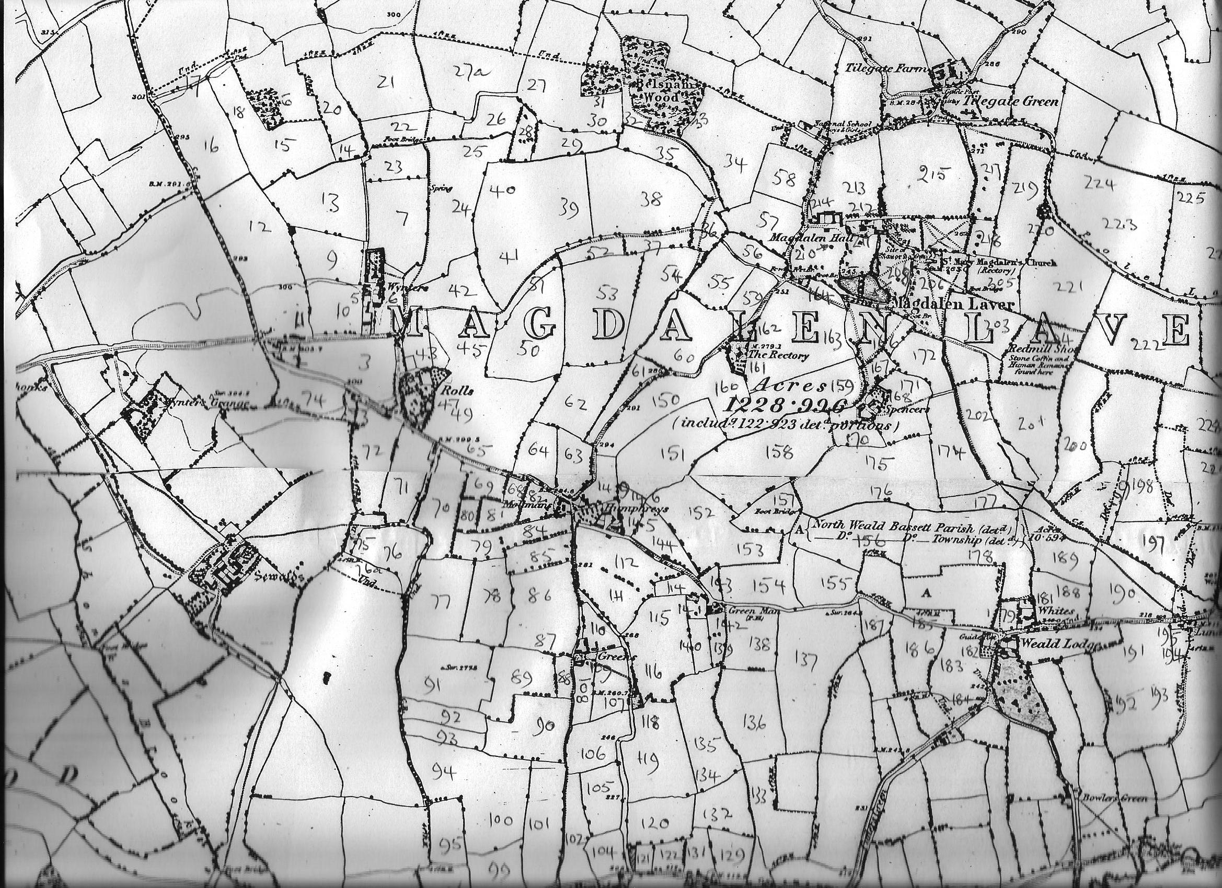
Map 1
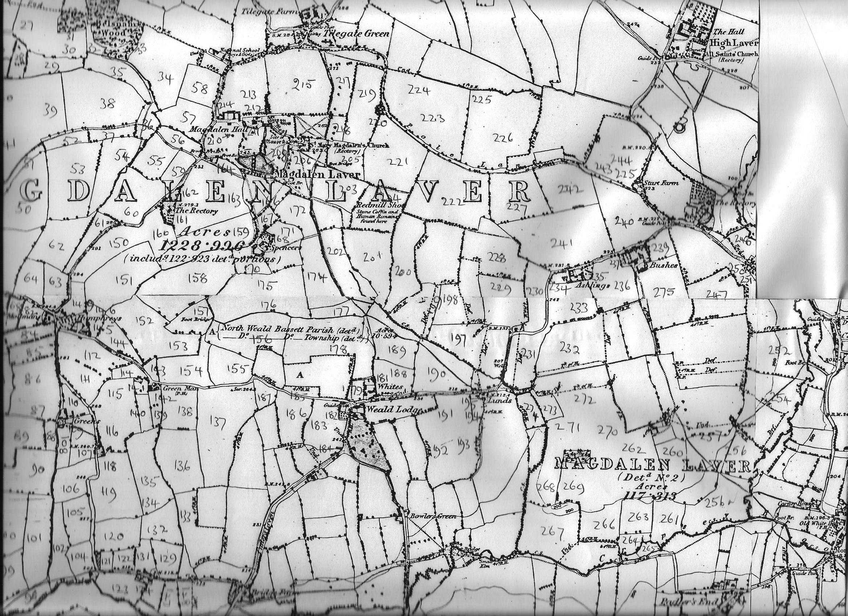
Map 2
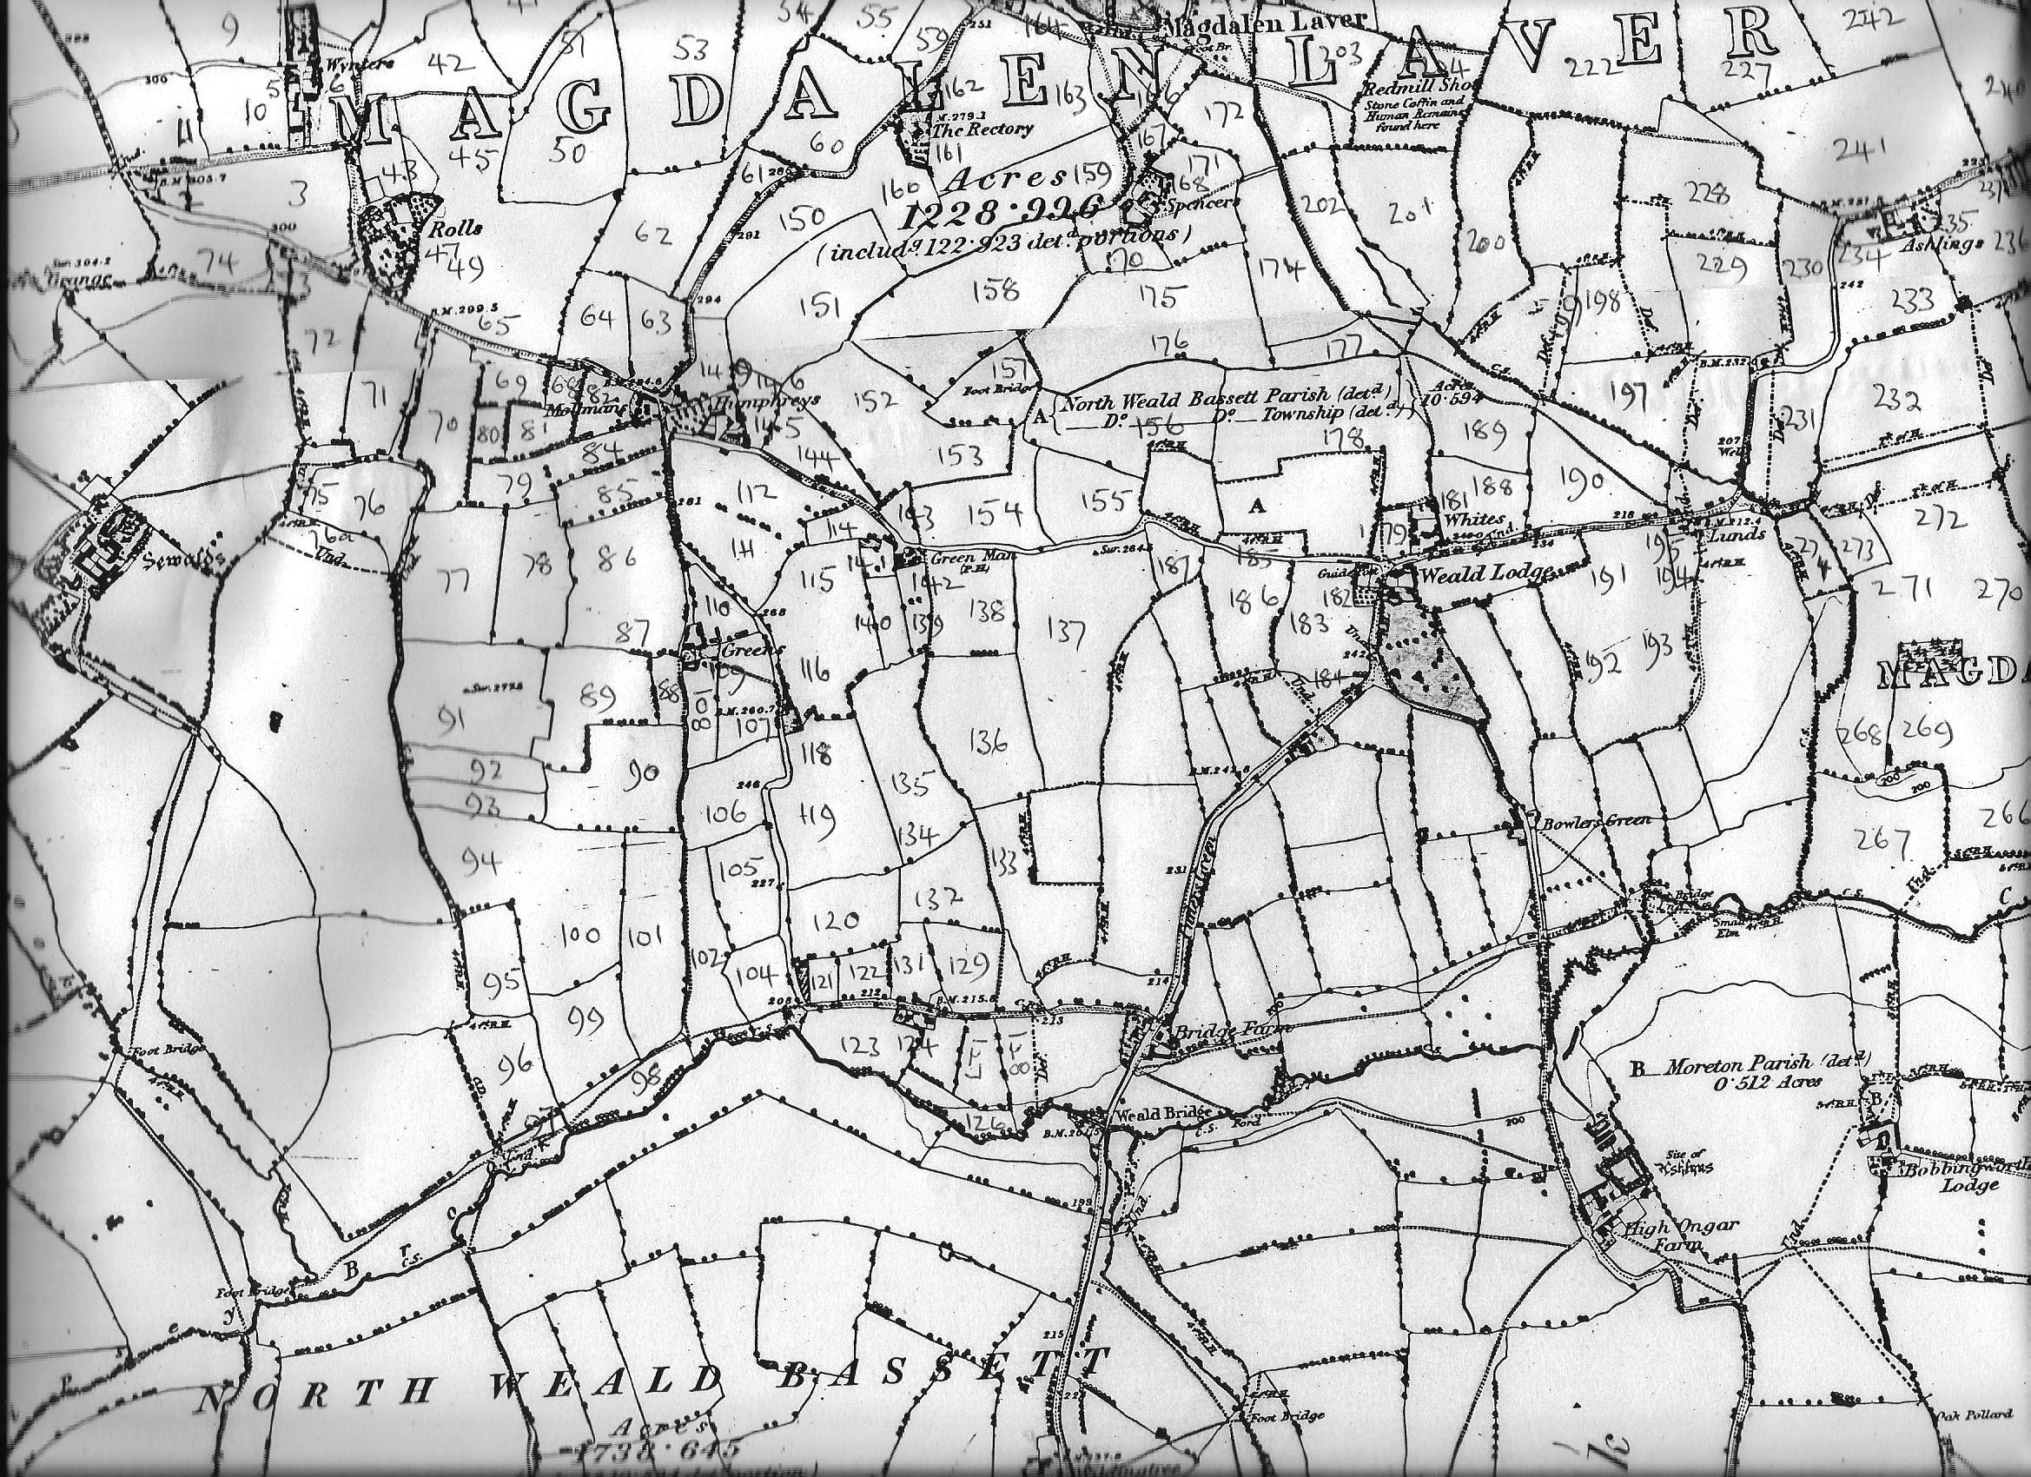
Map 3

